P2807.6™/D1.0
IEEE Guide for the Architectural Framework and Application of Educational Knowledge Graph
Developed by the

Knowledge Engineering Standards Committee
of the

IEEE Computer Society

Approved <Date Approved>

IEEE SA Standards Board

Copyright © 2026 by The Institute of Electrical and Electronics Engineers, Inc.
Three Park Avenue
New York, New York 10016-5997, USA
All rights reserved.
This document is an unapproved draft of a proposed IEEE Standard. As such, this document is subject to change. USE AT YOUR OWN RISK! IEEE copyright statements SHALL NOT BE REMOVED from draft or approved IEEE standards, or modified in any way. Because this is an unapproved draft, this document must not be utilized for any conformance/compliance purposes. Permission is hereby granted for officers from each IEEE Standards Working Group or Committee to reproduce the draft document developed by that Working Group for purposes of international standardization consideration. IEEE Standards Department must be informed of the submission for consideration prior to any reproduction for international standardization consideration (stds-ipr@ieee.org). Prior to adoption of this document, in whole or in part, by another standards development organization, permission must first be obtained from the IEEE Standards Department (stds-ipr@ieee.org). When requesting permission, IEEE Standards Department will require a copy of the standard development organization's document highlighting the use of IEEE content. Other entities seeking permission to reproduce this document, in whole or in part, must also obtain permission from the IEEE Standards Department.
IEEE Standards Department
445 Hoes Lane
Piscataway, NJ 08854, USA

Abstract: This guide defines a comprehensive framework for representing, integrating, and utilizing knowledge graphs in the domain of education. It covers the core ontology, data specifications, implementation guidelines, use cases, and best practices for constructing, maintaining, and leveraging educational knowledge graphs (EDUKGs) across various educational levels and contexts. The guide introduces a common vocabulary and data model for representing educational knowledge in a structured, machine-readable format, facilitating interoperability and reusability across different systems and platforms. It supports the development of intelligent and personalized educational applications, such as recommendation systems, question-answering engines, and adaptive learning platforms. Furthermore, the guide provides guidance on integrating EDUKGs with large language models (LLMs) and graph-based retrieval augmented generation (Graph-RAG) techniques, enabling advanced natural language processing and knowledge retrieval capabilities in educational applications. By leveraging semantic web technologies, graph databases, and AI/ML techniques, this guide aims to enhance personalized learning, intelligent tutoring, curriculum design, and educational analytics, ultimately transforming the landscape of educational technology.

Keywords: Educational Knowledge Graph; Semantic Web; Ontology; Knowledge Representation; Graph Database; Learning Analytics; Adaptive Learning; Personalized Education; Intelligent Tutoring Systems; Large Language Models; Graph-based Retrieval Augmented Generation; Graph-RAG; Curriculum Design; Educational Data Mining; Interoperability; E-learning; Artificial Intelligence in Education; Learning Object Metadata; Competency Framework; Learning Management System; Ethics in AI; Data Security

•
Important Notices and Disclaimers Concerning IEEE Standards Documents
IEEE Standards documents are made available for use subject to important notices and legal disclaimers. These notices and disclaimers, or a reference to this page (https://standards.ieee.org/ipr/disclaimers.html), appear in all IEEE standards and may be found under the heading “Important Notices and Disclaimers Concerning IEEE Standards Documents.”

Notice and Disclaimer of Liability Concerning the Use of IEEE Standards Documents
IEEE Standards documents are developed within IEEE Societies and subcommittees of IEEE Standards Association (IEEE SA) Board of Governors. IEEE develops its standards through an accredited consensus development process, which brings together volunteers representing varied viewpoints and interests to achieve the final product. IEEE standards are documents developed by volunteers with scientific, academic, and industry-based expertise in technical working groups. Volunteers involved in technical working groups are not necessarily members of IEEE or IEEE SA and participate without compensation from IEEE. While IEEE administers the process and establishes rules to promote fairness in the consensus development process, IEEE does not independently evaluate, test, or verify the accuracy of any of the information or the soundness of any judgments contained in its standards.
IEEE makes no warranties or representations concerning its standards, and expressly disclaims all warranties, express or implied, concerning all standards, including but not limited to the warranties of merchantability, fitness for a particular purpose and non-infringement IEEE Standards documents do not guarantee safety, security, health, or environmental protection, or compliance with law, or guarantee against interference with or from other devices or networks. In addition, IEEE does not warrant or represent that the use of the material contained in its standards is free from patent infringement. IEEE Standards documents are supplied “AS IS” and “WITH ALL FAULTS.”
Use of an IEEE standard is wholly voluntary. The existence of an IEEE standard does not imply that there are no other ways to produce, test, measure, purchase, market, or provide other goods and services related to the scope of the IEEE standard. Furthermore, the viewpoint expressed at the time a standard is approved and issued is subject to change brought about through developments in the state of the art and comments received from users of the standard.
In publishing and making its standards available, IEEE is not suggesting or rendering professional or other services for, or on behalf of, any person or entity, nor is IEEE undertaking to perform any duty owed by any other person or entity to another. Any person utilizing any IEEE Standards document should rely upon their own independent judgment in the exercise of reasonable care in any given circumstances or, as appropriate, seek the advice of a competent professional in determining the appropriateness of a given IEEE standard.
IN NO EVENT SHALL IEEE BE LIABLE FOR ANY DIRECT, INDIRECT, INCIDENTAL, SPECIAL, EXEMPLARY, OR CONSEQUENTIAL DAMAGES (INCLUDING, BUT NOT LIMITED TO: THE NEED TO PROCURE SUBSTITUTE GOODS OR SERVICES; LOSS OF USE, DATA, OR PROFITS; OR BUSINESS INTERRUPTION) HOWEVER CAUSED AND ON ANY THEORY OF LIABILITY, WHETHER IN CONTRACT, STRICT LIABILITY, OR TORT (INCLUDING NEGLIGENCE OR OTHERWISE) ARISING IN ANY WAY OUT OF THE PUBLICATION, USE OF, OR RELIANCE UPON ANY STANDARD, EVEN IF ADVISED OF THE POSSIBILITY OF SUCH DAMAGE AND REGARDLESS OF WHETHER SUCH DAMAGE WAS FORESEEABLE.

Translations
The IEEE consensus balloting process involves the review of documents in English. In the event that an IEEE standard is translated, the English language version published by IEEE is the guiding document.

Use by artificial intelligence systems
In no event shall material in any IEEE Standards documents be used for the purpose of creating, training, enhancing, developing, maintaining, or contributing to any artificial intelligence systems without the express, written consent of IEEE SA in advance. “Artificial intelligence” refers to any software, application, or other system that uses artificial intelligence, machine learning, or similar technologies, to analyze, train, process, or generate content. Requests for consent can be submitted using the Contact Us form.

Official statements
A statement, written or oral, that is not processed in accordance with the IEEE SA Standards Board Operations Manual is not, and shall not be considered or inferred to be, the official position of IEEE or any of its committees and shall not be considered to be, or be relied upon as, a formal position of IEEE or IEEE SA. At lectures, symposia, seminars, or educational courses, an individual presenting information on IEEE standards shall make it clear that the presenter’s views should be considered the personal views of that individual rather than the formal position of IEEE, IEEE SA, the Standards Committee, or the Working Group. Statements made by volunteers may not represent the formal position of their employer(s) or affiliation(s). News releases about IEEE standards issued by entities other than IEEE SA should be considered the view of the entity issuing the release rather than the formal position of IEEE or IEEE SA.

Comments on standards
Comments for revision of IEEE Standards documents are welcome from any interested party, regardless of membership affiliation with IEEE or IEEE SA. However, IEEE does not provide interpretations, consulting information, or advice pertaining to IEEE Standards documents.
Suggestions for changes in documents should be in the form of a proposed change of text, together with appropriate supporting comments. Since IEEE standards represent a consensus of concerned interests, it is important that any responses to comments and questions also receive the concurrence of a balance of interests. For this reason, IEEE and the members of its Societies and subcommittees of the IEEE SA Board of Governors are not able to provide an instant response to comments or questions, except in those cases where the matter has previously been addressed. For the same reason, IEEE does not respond to interpretation requests. Any person who would like to participate in evaluating comments or revisions to an IEEE standard is welcome to join the relevant IEEE SA working group. You can indicate interest in a working group using the Interests tab in the Manage Profile & Interests area of the IEEE SA myProject system. An IEEE Account is needed to access the application.
Comments on standards should be submitted using the Contact Us form.

Laws and regulations
Users of IEEE Standards documents should consult all applicable laws and regulations. Compliance with the provisions of any IEEE Standards document does not constitute compliance to any applicable regulatory requirements. Implementers of the standard are responsible for observing or referring to the applicable regulatory requirements. IEEE does not, by the publication of its standards, intend to urge action that is not in compliance with applicable laws, and these documents may not be construed as doing so.

Data privacy
Users of IEEE Standards documents should evaluate the standards for considerations of data privacy and data ownership in the context of assessing and using the standards in compliance with applicable laws and regulations.

Copyrights
IEEE draft and approved standards are copyrighted by IEEE under U.S. and international copyright laws. They are made available by IEEE and are adopted for a wide variety of both public and private uses. These include both use by reference, in laws and regulations, and use in private self-regulation, standardization, and the promotion of engineering practices and methods. By making these documents available for use and adoption by public authorities and private users, neither IEEE nor its licensors waive any rights in copyright to the documents.

Photocopies
Subject to payment of the appropriate licensing fees, IEEE will grant users a limited, non-exclusive license to photocopy portions of any individual standard for company or organizational internal use or individual, non-commercial use only. To arrange for payment of licensing fees, please contact Copyright Clearance Center, Customer Service, 222 Rosewood Drive, Danvers, MA 01923 USA; +1 978 750 8400; https://www.copyright.com/. Permission to photocopy portions of any individual standard for educational classroom use can also be obtained through the Copyright Clearance Center.

Updating of IEEE Standards documents
Users of IEEE Standards documents should be aware that these documents may be superseded at any time by the issuance of new editions or may be amended from time to time through the issuance of amendments, corrigenda, or errata. An official IEEE document at any point in time consists of the current edition of the document together with any amendments, corrigenda, or errata then in effect.
Every IEEE standard is subjected to review at least every 10 years. When a document is more than 10 years old and has not undergone a revision process, it is reasonable to conclude that its contents, although still of some value, do not wholly reflect the present state of the art. Users are cautioned to check to determine that they have the latest edition of any IEEE standard.
In order to determine whether a given document is the current edition and whether it has been amended through the issuance of amendments, corrigenda, or errata, visit IEEE Xplore or contact IEEE. For more information about the IEEE SA or IEEE’s standards development process, visit the IEEE SA Website.

Errata
Errata, if any, for all IEEE standards can be accessed on the IEEE SA Website. Search for standard number and year of approval to access the web page of the published standard. Errata links are located under the Additional Resources Details section. Errata are also available in IEEE Xplore. Users are encouraged to periodically check for errata.

Patents
IEEE standards are developed in compliance with the IEEE SA Patent Policy.
Attention is called to the possibility that implementation of this standard may require use of subject matter covered by patent rights. By publication of this standard, no position is taken by the IEEE with respect to the existence or validity of any patent rights in connection therewith. If a patent holder or patent applicant has filed a statement of assurance via an Accepted Letter of Assurance, then the statement is listed on the IEEE SA Website at https://standards.ieee.org/about/sasb/patcom/patents.html. Letters of Assurance may indicate whether the Submitter is willing or unwilling to grant licenses under patent rights without compensation or under reasonable rates, with reasonable terms and conditions that are demonstrably free of any unfair discrimination to applicants desiring to obtain such licenses.
Essential Patent Claims may exist for which a Letter of Assurance has not been received. The IEEE is not responsible for identifying Essential Patent Claims for which a license may be required, for conducting inquiries into the legal validity or scope of Patents Claims, or determining whether any licensing terms or conditions provided in connection with submission of a Letter of Assurance, if any, or in any licensing agreements are reasonable or non-discriminatory. Users of this standard are expressly advised that determination of the validity of any patent rights, and the risk of infringement of such rights, is entirely their own responsibility. Further information may be obtained from the IEEE Standards Association.

IMPORTANT NOTICE
Technologies, application of technologies, and recommended procedures in various industries evolve over time. The IEEE standards development process allows participants to review developments in industries, technologies, and practices, and to determine what, if any, updates should be made to the IEEE standard. During this evolution, the technologies and recommendations in IEEE standards may be implemented in ways not foreseen during the standard’s development. IEEE standards development activities consider research and information presented to the standards development group in developing any safety recommendations. Other information about safety practices, changes in technology or technology implementation, or impact by peripheral systems also may be pertinent to safety considerations during implementation of the standard. Implementers and users of IEEE Standards documents are responsible for determining and complying with all appropriate safety, security, environmental, health, data privacy, and interference protection practices and all applicable laws and regulations.

Participants
At the time this draft guide was completed, the EDUKG Working Group had the following membership:
Bin Xu, Chair
Yanyan Li, Vice Chair
Joleen Jing Liang, Secretary
Organization Represented | Name of Representative
Tsinghua University | Jing Du
Beijing Normal University | Penghe Chen
Squirrel AI | Derek Haoyang Li
Beijing Knowledge Atlas Technology Joint Stock Company Limited | Yakun Li
Tianjin University | Xiaowang Zhang
Shanghai Jiao Tong University | Liping Shen
Institute of Computing Technology, CAS | Xinlong Jiang
Zhongke Letin Intelligent Technology (Jinan) Co., Ltd | Chenlong Gao
East China Normal University | Yonghe Wu
Chinese Academy of Medical Sciences | Jiangbo Pu
Inspur Yunzhou Industrial Internet Co., Ltd.（Inspur Group） | Shaohua Wang
Lenovo Research Institute | Xiaoping Zhang
Intel | Jane Wu
Shenzhen University | Weili Liu
Inspur Group | Yonghui Lü
China Electronics Standardization Institute | Yuntao Yu
Hainan Normal University | Bo Liao

The working group gratefully acknowledges the contributions of the following participants:
Hanming Li | Zheng Tan | Ruiyu Li
Richard Tong | Qian Chen | Zhanjie Wu
Jessie Tong | Cong Huang | Xin Wang

The following members of the <individual/entity> Standards Association balloting group voted on this standard. Balloters may have voted for approval, disapproval, or abstention.
[To be supplied by IEEE]

Balloter1
Balloter2
Balloter3
Balloter4
Balloter5
Balloter6
Balloter7
Balloter8
Balloter9

When the IEEE SA Standards Board approved this standard on <Date Approved>, it had the following membership:
[To be supplied by IEEE]

<Name>, Chair

<Name>, Vice Chair

<Name>, Past Chair

<Name>, Secretary

SBMember1
SBMember2
SBMember3
SBMember4
SBMember5
SBMember6
SBMember7
SBMember8
SBMember9

*Member Emeritus

Introduction
This introduction is not part of P2807.6/D1.0, Draft Guide for the Architectural Framework and Application of Educational Knowledge Graph.
The rapid advancement of digital technologies has created unprecedented opportunities to enhance and personalize educational experiences. Among the emerging technologies, knowledge graphs have gained increasing attention for their potential to fundamentally transform how educational content is organized, accessed, and utilized. In response to the growing need for structured, interoperable, and intelligent representations of educational knowledge, this guide introduces a comprehensive framework for Educational Knowledge Graphs (EDUKG), providing a common foundation for their design, implementation, and application across diverse educational contexts.
Traditional educational systems often face significant challenges in efficiently organizing, managing, and retrieving large volumes of heterogeneous educational content. At the same time, the rising demand for personalized learning, adaptive instruction, and data-driven decision-making calls for more advanced approaches to knowledge representation and management. EDUKG addresses these challenges by offering a flexible, scalable, and semantically rich structure that enables the systematic organization of educational data, supports meaningful relationships among learning concepts, and facilitates intelligent educational services.
Contents

1. Overview 12
1.1 Scope 12
1.2 Purpose 12
1.3 Word usage 12
2. Normative references 13
3. Definitions, acronyms, and abbreviations 13
3.1 Definitions 13
3.2 Acronyms and abbreviations 14
4. General 15
4.1 Overview 15
4.2 Guide structure 15
4.3 Stakeholders 16
5. Core ontology of EDUKG 18
5.1 Overview 18
5.2 Ontology classes and organizational structures 19
5.3 Class specifications 20
5.4 Relationships in EDUKG 22
5.5 EDUKG ontology format 23
6. Reference architecture for EDUKG-Enabled systems 24
6.1 Overview 24
6.2 Functional components 24
6.3 Technical implementation and use cases 26
7. EDUKG lifecycle and construction 26
7.1 Conceptual lifecycle of EDUKG 26
7.2 Technical construction of EDUKG and implementation of enabled applications 27
8. Security, privacy, and ethics 29
8.1 Data security 29
8.2 Privacy protection 29
8.3 Ethical considerations 30
Annex A (informative) knowledge graph sample based on CS106A programming methodology 31
Annex B (informative) EDUKG ontology and sample RDF documents in turtle format 35
Annex C (informative) Application scenarios of EDUKG 84
Annex D (informative) Case studies 91
Annex E (informative) EDUKG implementation 93
Reference 98

IEEE Guide for the Architectural Framework and Application of Educational Knowledge Graph
- Overview
  - Scope
This guide defines a comprehensive framework for representing, integrating, and utilizing knowledge graphs in the domain of education. It covers the core ontology, data specifications, implementation guides, use cases, and best practices for constructing, maintaining, and leveraging educational knowledge graphs. The standard encompasses the following educational levels and contexts: (1) Kindergarten to twelfth grade (K-12) education; (2) Higher education, including undergraduate and graduate programs; (3) Vocational education and training; (4) Continuing education and professional development; (5) Special education.
  - Purpose
The main purposes of the guide are: (1) To provide a common vocabulary, data model, and ontology for representing educational knowledge in a structured and machine-readable format across various educational levels and contexts. (2) To facilitate the integration, exchange and reuse of educational knowledge across different systems, platforms, and application. (3) To enable the development of intelligent and personalized educational applications, such as recommendation systems, question-answering engines, and adaptive learning platforms. (4) To foster collaboration, innovation, and best practices in the field of educational knowledge graph research and development. (5) To support the integration of Large Language Models (LLMs) and Graph-based Retrieval Augmented Generation (Graph-RAG) techniques with educational knowledge graphs, enabling advanced natural language processing and knowledge retrieval capabilities in educational applications. (6) To provide a foundation for leveraging the combined strengths of knowledge graphs and LLMs, such as symbolic reasoning, language understanding, and efficient knowledge retrieval, in the context of education.
  - Word usage
<This subclause is mandatory, and the definitions of shall, should, may, and can appear as defined in 6.4.7 of the IEEE SASB Operations Manual and shall not be modified.>
The word shall indicates mandatory requirements strictly to be followed in order to conform to the standard and from which no deviation is permitted (shall equals is required to).,
The word should indicates that among several possibilities one is recommended as particularly suitable, without mentioning or excluding others; or that a certain course of action is preferred but not necessarily required (should equals is recommended that).
The word may is used to indicate a course of action permissible within the limits of the standard (may equals is permitted to).
The word can is used for statements of possibility and capability, whether material, physical, or causal (can equals is able to).
- Normative references
The following referenced documents are indispensable for the application of this document (i.e., they must be understood and used, so each referenced document is cited in text and its relation to this document is explained). For dated references, only the edition cited applies. For undated references, the latest edition of the referenced document (including any amendments or corrigenda) applies.

IEEE Std 9274.1.1™-2023, IEEE Standard for Learning Technology—JavaScript Object Notation (JSON) Data Model Format and Representational State Transfer (RESTful) Web Service for Learner Experience Data Tracking and AccessExperience API (xAPI) Standard Data Privacy Process.
- Definitions, acronyms, and abbreviations
  - Definitions
For the purposes of this document, the following terms and definitions apply. The IEEE Standards Dictionary Online should be consulted for terms not defined in this clause.
knowledge: Facts, opinions, actions, or skills acquired through learning, practicing, or exploring.
knowledge graph: Assemblies of knowledge elements and their relationships described in a structured form.
document-based knowledge exchange: Knowledge exchange conducted in the form of documents as knowledge carriers.
ontology: A model to describe entity types, entity attributes, and relationships among them.
entity: An object existed independently in the real world.
attribute (property): A characteristic of an entity, typically represented as key-value pairs associated with a node in a knowledge graph.
relationship (edge): A connection or association between two entities in a knowledge graph, representing the semantic or contextual link between them.
object property: A binary relationship between two entities, representing a connection or association between them.
data property: A binary relationship between an entity and a literal value (e.g., string, number, or date).
learning point: A unit of knowledge or a specific concept intended to be learned or mastered by a student.
learning resource: Any digital or non-digital material used to support the learning process, such as textbooks, videos, simulations, or assessments.
pedagogical rules: A set of principles, guidelines, or strategies that govern the design, delivery, and evaluation of instruction to facilitate effective learning.
educational knowledge graph: A knowledge graph specifically designed to represent and organize knowledge relevant to the domain of education, encompassing entities such as learning points, learning resources, and pedagogical rules.
  - Acronyms and abbreviations
AI artificial intelligence
API application programming interface
EDUKG educational knowledge graph
Graph-RAG graph-based retrieval augmented generation
ITS Intelligent Tutoring System
KG knowledge graph
LLM large language model
LMS learning management system
LO learning object
LOM learning object metadata
ML machine learning
NLP natural language processing
OWL web ontology language
RDF resource description framework
RDFS resource description framework schema
SCORM sharable content object reference model
SPARQL SPARQL protocol and RDF query language
URI uniform resource identifier
URL uniform resource locator
xAPI experience API
- General
  - Overview
The EDUKG is designed to provide a standardized, machine-readable representation of educational knowledge, encompassing learning points, resource items, and pedagogical rules. By establishing a common semantic framework, EDUKG facilitates interoperability across heterogeneous educational systems and supports the development of AI-driven learning environments.
The primary objective of EDUKG is to enable the seamless exchange and reuse of educational knowledge across organizational boundaries. Key design considerations include:
- Interoperability: Alignment with existing standards (e.g., DCMI, SCORM, xAPI) to support consistent discovery and integration.
- AI-ready infrastructure: Providing structured contextual grounding for advanced technologies such as LLMs, Graph-RAG, and vector search.
- Scalability: Support for diverse storage technologies, including RDF triple stores and graph databases, independent of specific implementation platforms.
  - Guide structure
The structure of this guide is organized into three primary sections, each addressing a critical dimension of the EDUKG ecosystem. Figure 1 illustrates the hierarchical relationship between these sections and their key components.
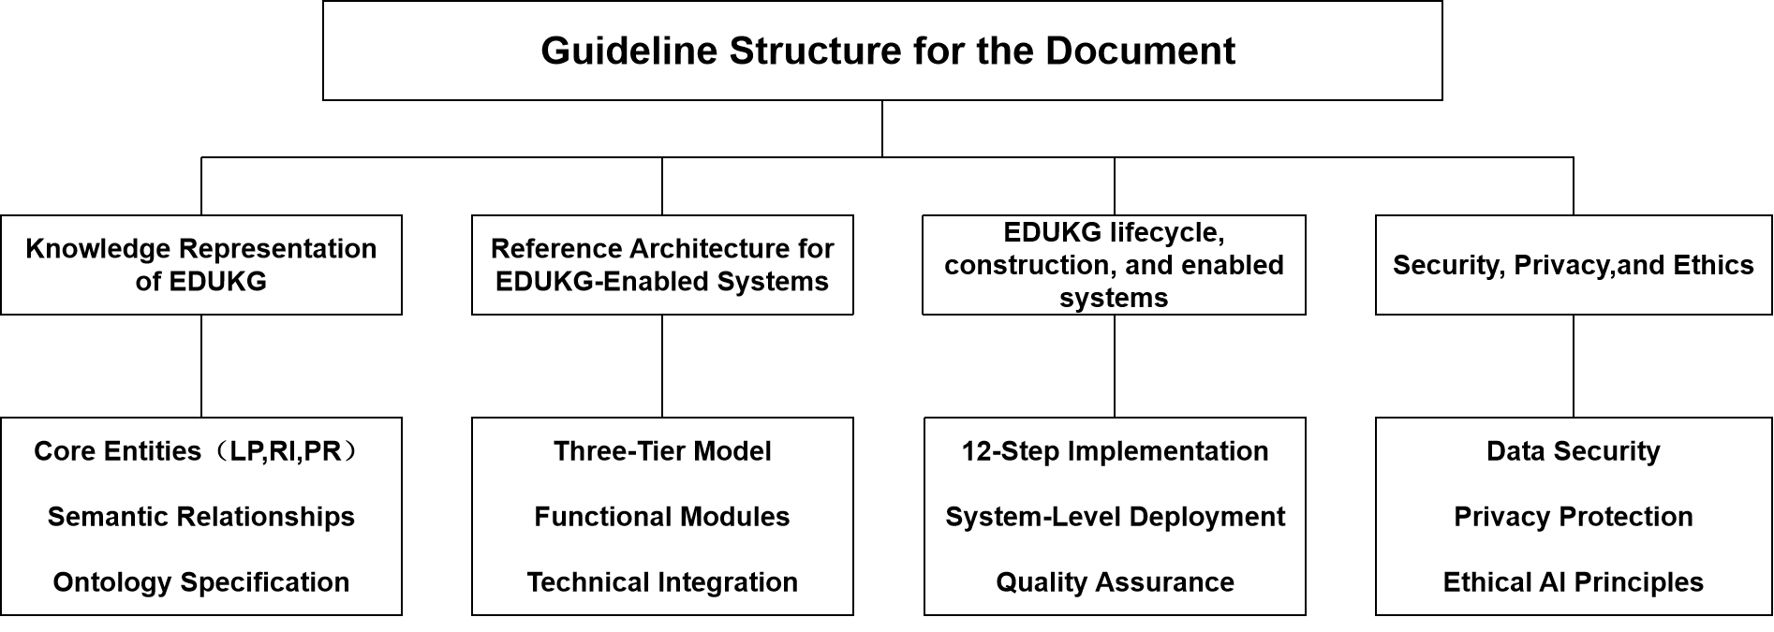
- —Guideline structure for the document
As depicted in the framework structure, the guide is divided into the following main sections:
- Knowledge representation of EDUKG: section 5 defines the conceptual foundation of EDUKG. It specifies the core entities—Learning Points (LP), Resource Items (RI), and Pedagogical Rules (PR)—and the semantic relationships that interconnect them.
- Reference Architecture for EDUKG-enabled Systems: section 6 establishes a three-tier technical framework (Front-End, Middle, and Back-End) for building EDUKG-enabled systems, providing a blueprint for interoperable educational applications.
- EDUKG lifecycle, construction, and enabled systems: section 7 provides a systematic 12-step technical workflow for constructing, maintaining, and deploying an EDUKG, as well as implementing applications built on top of it. It covers the entire data lifecycle, from initial ontology design to application-level integration and final deployment.
- Security, Privacy, and Ethics: section 8 outlines key principles for the security, privacy, and ethical use of EDUKG and its enabled systems, covering data protection, regulatory compliance, and responsible deployment.
  - Stakeholders
As illustrated in Figure 2, the stakeholders of the EDUKG-enabled systems are as follows:
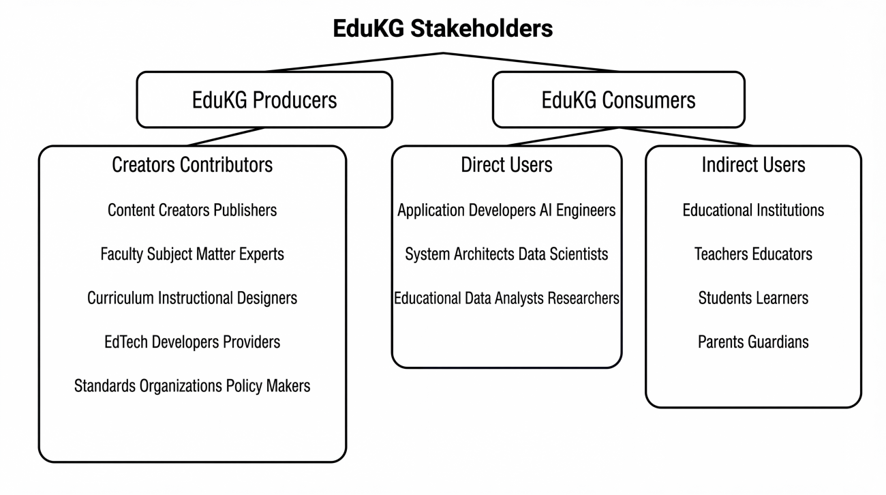
- —EDUKG Stakeholders: Producers and Consumers
- EDUKG producers: This group includes the Creators and Contributors responsible for the development and standardization of the knowledge graph:
  - Content creators and publishers: Develop and annotate educational resources.
  - Faculty and subject matter experts: Provide domain-specific knowledge and validation.
  - Curriculum and instructional designers: Define learning objectives and pedagogical structures.
  - EdTech developers and providers: Build the tools and platforms that host the EDUKG.
  - Standards organizations and policy makers: Promote alignment with broader educational and technical standards.
- EDUKG consumers: This group is further divided into direct and indirect users of the knowledge graph:
  - Direct users: Technical stakeholders who build and analyze EDUKG-enabled systems, including Application Developers AI Engineers, System Architects Data Scientists, Educational Data Analysts Researchers.
  - Indirect users: The end beneficiaries of the EDUKG ecosystem, including Educational Institutions, Teachers Educators, Students Learners, Parents Guardians.
- Core ontology of EDUKG
  - Overview
At a high level, the EDUKG ontology organizes information around:
- Ontology classes:
  - LearningPoints (LPitem): Fine-grained units of knowledge (e.g., specific concepts, objectives, or skills).
  - ResourceItems (RIitem): Various learning resources or materials (e.g., lessons, assessments,interactive tools).
  - PedagogicalRuleItems (PRitem): Pedagogical strategies or rules (e.g., instructional plans,feedback mechanisms) following a KSTAR-like structure as defined to represent knowledge in a generalized agentic form.
  - CollectionsAndReferences:
    - LearningPointCollection: Groupings of learning points with versioning and dependency management.
    - CollectionDependency: Dependencies or prerequisites linking multiple collections.
    - ExternalReference: External references that link a learning point to an external source or framework.
- Edges(Relationship): Semantic connections among these entities, including hierarchical structures, prerequisite relationships, references, and cross-entity links.
- Properties(Attributes): Descriptors of entities and their connections, defined as either data properties (linking nodes to literal values) or object properties (linking nodes to other nodes). Common examples include:
  - Required properties: identifier, title, itemType.
  - Optional properties: tags, humanAssignedId, contentJson, lastChangeDateTime, etc.
- Organization: Hierarchical structuring of learning points within subjects, topics, and sub-topics, as well as collection-based organization with explicit versioning and dependencies.
  - Ontology classes and organizational structures
    - Core ontology classes
The core classes in the EDUKG ontology are organized around a common abstract superclass, BaseEntity. As shown in Figure 3, LPitem, RIitem, and PRitem are defined as specialized subclasses that inherit shared identifiers and metadata properties from Base entity, while introducing entity-specific semantics.
- BaseEntity: An abstract foundational class for all EDUKG entities, providing core properties such as identifier (a GUID), title, and item type.
- LPitem (Learning point): A class representing an individual learning point or concept. Examples might be learning objectives or specific knowledge items.
- RIitem (Resource item): A class representing any educational resource, including lessons, assessments, simulations, games, or reference materials.
- PRitem (Pedagogical rule): A class representing pedagogical strategies or rules. According to the ontology, each rule can specify KSTAR-like data, such as an actor role, situation, task, action plan, and expected result.
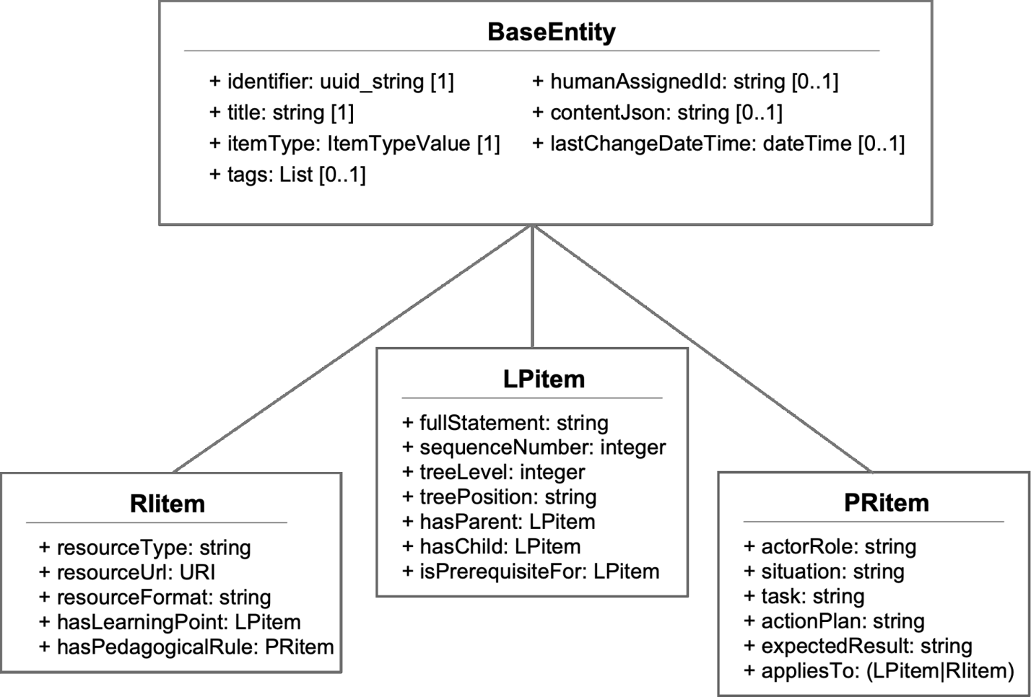
- —Class inheritance from BaseEntity
    - Organizational structures and references
The relationships among learning point collections, their dependencies, and external references are illustrated in Figure 4.
- LearningPointCollection: Represents a set of learning points (e.g., a curriculum framework or a group of standards) with its own collection URI and version.
- CollectionDependency: Specifies how one collection depends on another (e.g., an alignment, extension, prerequisite, or reference).
- ExternalReference: Connects LPitem entities to external collections via a URI and identifier.
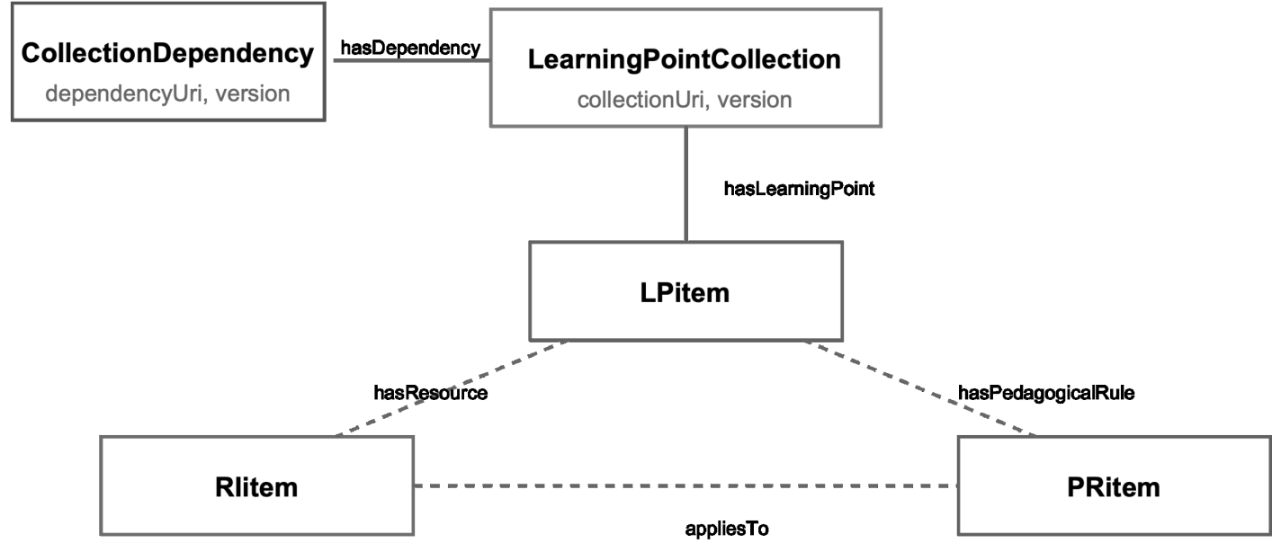
- —Learning point collections and external references
  - Class specifications
    - Learning points (LPitem)
- Base class: LPitem
- Key properties:
  - identifier, title, itemType (required)
  - tags, humanAssignedId, contentJson, lastChangeDateTime, fullStatement (optional)
  - sequenceNumber, treeLevel, treePosition (for hierarchical arrangement)
- Internal relationships:
  - hasParent/hasChild (hierarchical organization)
  - isPrerequisiteFor/hasPrerequisite (prerequisite structure)
  - isEquivalentTo (equivalent or exact match)
  - isBroaderThan/isNarrowerThan (broader/narrower conceptual links)
  - isRelatedTo (related concepts)
    - Resource items (RIitem)
The classification of resource items into different instructional categories is shown in Figure 5.
- Base class: RIitem
- Key properties:
  - identifier, title, itemType (required)
  - tags, humanAssignedId, contentJson, lastChangeDateTime (optional)
  - resourceType (instructional items, assessment items, interactive learning task items, and their subtypes)
  - resourceUrl, resourceFormat
    - Pedagogical rules (PRitem)
- Base class: PRitem
- Key properties:
  - identifier, title, itemType (required)
  - tags, humanAssignedId, contentJson, lastChangeDateTime (optional)
  - actorRole, situation, task, actionPlan, expectedResult
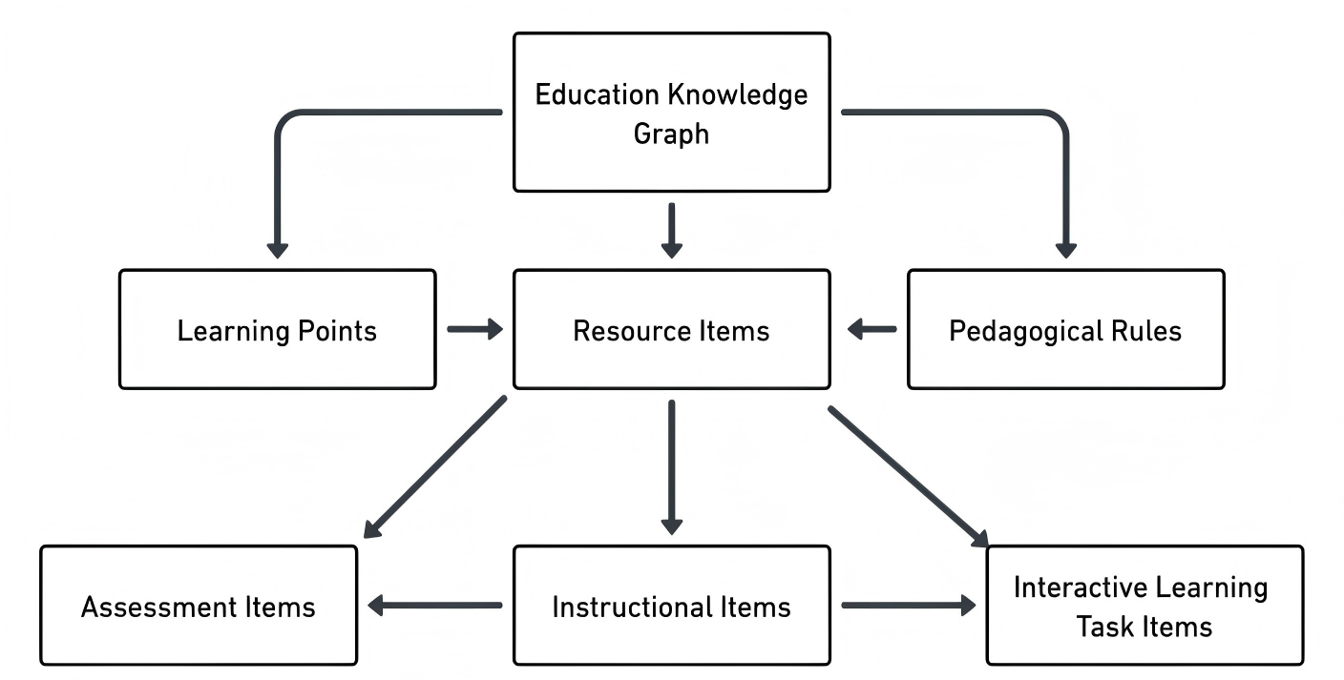
- —The three basic types of resource items
    - LearningPointCollection and CollectionDependency
- LearningPointCollection:
  - Inherits from BaseEntity (so it has identifier, title, itemType, etc.).
  - Properties include collectionUri (required), version, and hasDependency for managing references to other collections.
- CollectionDependency:
  - Represents how one collection depends on another (e.g., alignment, extension, prerequisite, reference).
  - Properties include dependencyUri (required), dependencyVersion, and dependencyPurpose.
    - ExternalReference
- ExternalReference:
  - Connects a learning point (LPitem) to an external collection or standard.
  - Properties include externalCollectionUri and externalIdentifier.
  - Relationships in EDUKG
    - Internal relationships
These relationships connect entities of the same type, such as the hierarchical and semantic relationships among learning points (LPitem) described earlier.
    - Cross-entity relationships
These relationships link different entity types using the following core object properties:
- hasLearningPoint: An entity (LearningPointCollection, RIitem, or PRitem) includes or links to a LPitem.
- hasResource: An entity (LPitem or PRitem) is associated with a RIitem.
- hasPedagogicalRule: An entity (LPitem or RIitem) is associated with a PRitem.
- appliesTo: A PRitem applies to a LPitem or RIitem.
    - Relationship types
The ontology defines specialized relationship types to express the specific nature of connections between entities:
- Standard Relationship Types:The ontology provides predefined relationship types as subclasses of ObjectProperty, including:
  - Contains: Indicates that one entity contains another as a component.
  - Supports: Indicates that one entity provides supporting content for another.
  - Implements: Indicates that one entity implements the guidelines of another.
  - Demonstrates: Indicates that one entity demonstrates the skills or knowledge of another.
  - Explains: Indicates that one entity explains the concepts of another.
  - practices: Indicates that one entity provides practice for another.
  - Assesses: Indicates that one entity assesses the knowledge or skills of another.
  - Extends: Indicates that one entity extends the content of another.
  - Prerequisite: Indicates that one entity is a prerequisite for another.
- Domain-specific Relationships: To accommodate specialized relationships that cannot be predefined in a general standard, the ontology includes:
  - DisciplinaryProperty: A subclass of owl:ObjectProperty specifically designed for domainspecific relationships between learning points. Examples include relationships like “net radiation composition” in hydrology or ”propagation process” in physics. This allows domain experts to define custom relationship types tailored to their specific disciplines.
To use these relationship types in practice, they are implemented as instances of their respective property classes rather than as property modifiers, following standard RDF and OWL [B15] conventions.
An example of a knowledge graph constructed based on this guide is provided in Annex A.
  - EDUKG ontology format
The EDUKG ontology specifies the schema using RDF and RDFS as the foundational technologies for knowledge representation and ontology definition. It defines core classes [such as BaseEntity, Learning Points (LPitem), Resource Items (RIitem), and Pedagogical Rules (PRitem)], their hierarchical inheritance, relationships, and properties. This framework enables consistent and interoperable modeling of educational content, integration with graph databases and embedding technologies, and querying via SPARQL [B13] to support intelligent applications. The complete EDUKG ontology, together with sample RDF documents, is provided in Terse RDF Triple Language (Turtle) [B14] format in Annex B.
- Reference architecture for EDUKG-Enabled systems
  - Overview
The EDUKG-enabled system is logically partitioned into three functional tiers: the Front-End Tier, the Middle Tier, and the Back-End Tier. This separation provides a clear division of responsibilities, from user interaction to intelligent processing and data management.
Figure 6 illustrates how these three tiers integrate to deliver adaptive learning experiences, support teacher workflows, and generate actionable administrative insights.
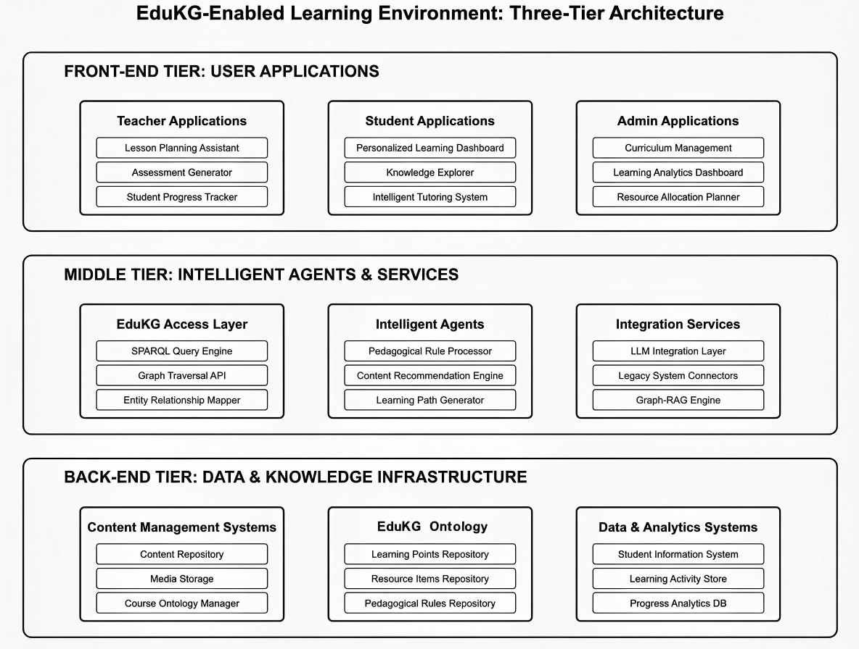
- —EDUKG Enabled Learning Environment Architecture
  - Functional components
The reference architecture defines the key technical elements within each tier to support a robust and standardized implementation.
    - Front-end tier
The Front-End Tier consists of user-facing applications designed for different stakeholders in the educational ecosystem:
- Teacher applications: Tools for lesson planning, automated assessment generation, and student progress tracking.
- Student applications: Personalized learning dashboards, knowledge graph explorers, and intelligent tutoring interfaces.
- Admin applications: Systems for curriculum management, institutional analytics dashboards, and resource planning.
    - Middle tier
The Middle Tier acts as the intelligence layer, providing services that utilize the underlying knowledge graph. This tier is critical for enabling advanced capabilities such as large language model (LLM) integration and semantic search. The Middle Tier is composed of the following functional components:
- EDUKG access module: Manages technical operations, including SPARQL queries, graph traversal, and entity-relationship mapping.
- Intelligent agents: Core intelligent agents that implement pedagogical rules, handle educational resources, and generate personalized recommendations or learning paths.
- Integration services: Facilitates connections between the EDUKG and LLMs, legacy educational systems, and implements Graph-RAG capabilities.
    - Back-end Tier
The Back-End Tier provides the foundational data and knowledge infrastructure:
- EDUKG ontology: The central knowledge repository containing learning points, resource items, pedagogical rules, and educational ontology mappings.
- Content management systems (CMS): Repositories for educational content with associated course ontology mappings.
- Data and analytics systems: Storage for student information, historical learning activities, and longitudinal progress data.
  - Technical implementation and use cases
The reference architecture defined in this section serves as a technical foundation for various educational applications. To support a successful implementation:
- Developers and architects could follow the integration strategies for LLMs and adaptive systems.
- The synergy between the EDUKG core and the Middle-tier agents enables the realization of the diverse educational scenarios (e.g., personalized learning and curriculum design) introduced in the opening sections of this guide and further detailed in Annex C.
- EDUKG lifecycle and construction
  - Conceptual lifecycle of EDUKG
The lifecycle of an EDUKG typically consists of three main phases: preparation, creation, and usage.
In the preparation phase, educational resources are collected, analyzed, and mapped to the EDUKG ontology.The creation phase focuses on constructing the knowledge graph by defining entities and relationships and generating RDF representations of the graph.In the usage phase, the knowledge graph supports querying, intelligent services, and integration with advanced technologies such as large language models. The whole lifecycle of EDUKG is illustrated in Figure 7:
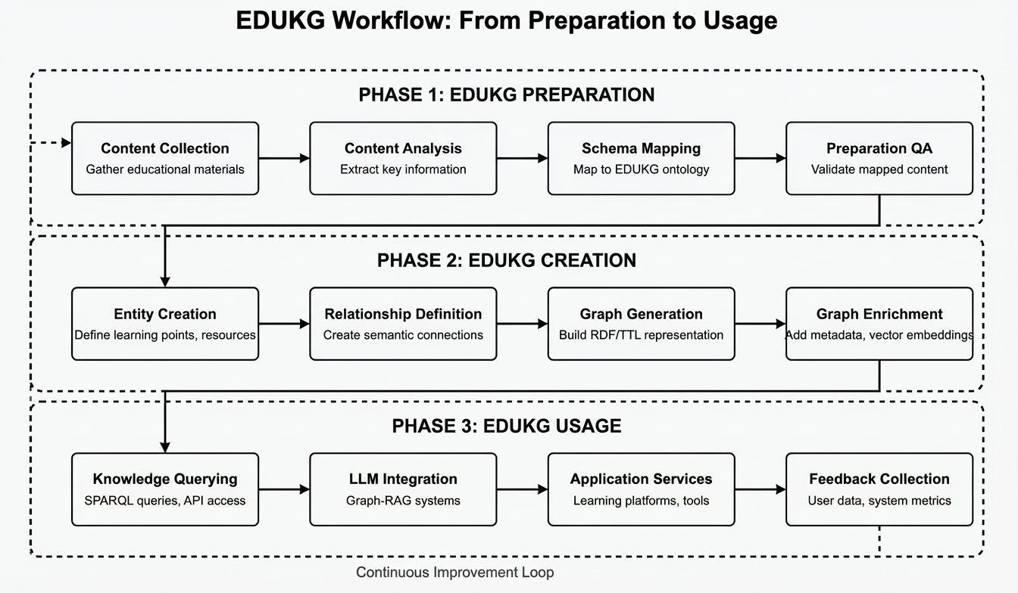
- —EDUKG Workflow: From Preparation to Usage
While the lifecycle describes the conceptual workflow of knowledge graph development and utilization, practical deployment requires a systematic technical implementation process.
  - Technical construction of EDUKG and implementation of enabled applications
The technical workflow of EDUKG covers two interconnected aspects: the construction of the knowledge graph itself and the implementation of applications built on top of it.
- Construction: Focuses on the knowledge graph, including ontology design, RDF data integration, graph database setup, and embedding database preparation.
- Implementation: Focuses on integrating these components with applications, such as large language models, APIs, and user interfaces, to support practical educational use cases
This workflow consists of a series of interconnected stages, ranging from initial infrastructure setup to advanced application integration. Following a structured sequence of activities can help facilitate a smooth and effective process.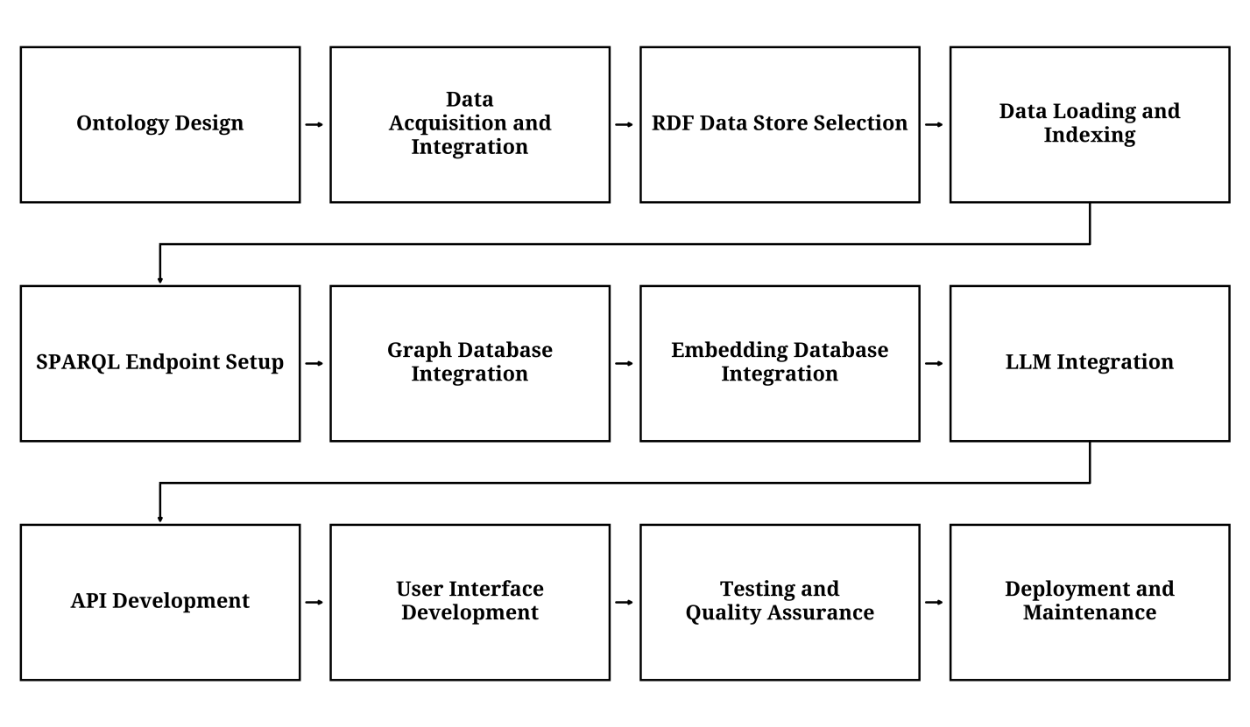
- —Workflow of EDUKG Construction and Application Integration
As illustrated in Figure 8, the workflow includes twelve key steps, described below:
- Ontology design: Begin by designing a comprehensive ontology that captures the key entities, relationships, and properties relevant to the educational domain. Consider existing educational standards and vocabularies, such as LRMI or DCMI, and extend them as needed to meet specific requirements. Use ontology development tools to create and visualize the ontology.
- Data acquisition and integration: Identify the various data sources that will contribute to the EDUKG, such as learning management systems, student information systems, and educational repositories. Develop data extraction, transformation, and loading (ETL) processes to convert the source data into RDF triples, adhering to the designed ontology.
- RDF data store selection: Choose an appropriate RDF data store based on factors such as scalability, performance, and compatibility with other technologies. Set up the selected data store and configure it to optimize storage and querying performance.
- Data loading and indexing: Load the RDF triples generated from the data integration pipeline into the RDF data store. Optimize the data loading process by using bulk loading techniques or parallel processing. Create appropriate indexes, such as subject-predicate-object indexes or full-text indexes, to enhance query performance.
- SPARQL endpoint setup: Configure a SPARQL endpoint to allow users and applications to query the EDUKG using the SPARQL query language. Use tools to set up the endpoint. Take measures to make the endpoint secure, performant, and accessible via standard protocols like HTTP or HTTPS.
- Graph database integration: If desired, integrate a graph database to leverage its graph traversal and analysis capabilities. Map the RDF data to the graph database’s native data model and establish a synchronization mechanism to keep the RDF data store and graph database in sync. Use tools like Neosemantics or RDF4J to facilitate the integration.
- Embedding database integration: Integrate an embedding database to enable semantic search and similarity-based retrieval. Extract entity embeddings from the EDUKG and index them in the embedding database. Develop search APIs that leverage the embedding database to provide semantic search functionalities.
- LLM integration: Integrate LLMs enable natural language understanding and generation capabilities. Fine-tune the LLMs on educational content and align them with the EDUKG’s ontology. Develop APIs that allow users to interact with the LLMs for question answering, content generation, and other natural language tasks.
- API development: Build a set of APIs that expose the functionalities of the EDUKG to external applications and users. Design RESTful APIs that allow for querying, searching, and manipulating the knowledge graph data. Implement authentication and authorization mechanisms.
- User interface development: Develop user-friendly interfaces that enable users to explore, query, and interact with the EDUKG. Create intuitive search and navigation interfaces, data visualization components, and collaboration features. Use modern web technologies to build responsive and interactive user interfaces.
- Testing and Quality Assurance: Implement comprehensive testing and quality assurance processes to support the reliability, performance, and accuracy of the EDUKG. Conduct unit testing, integration testing, and end-to-end testing to identify and fix any issues. Establish data validation and quality control mechanisms to maintain the integrity of the knowledge graph data.
- Deployment and maintenance: Deploy the EDUKG infrastructure in a scalable and secure environment, such as cloud-based or on-premises platforms. Set up monitoring and logging systems to track system performance, identify bottlenecks, and troubleshoot issues. Establish a maintenance and update schedule to keep the knowledge graph up to date with the latest data and technology stack.
For readers interested in concrete examples following this workflow, as well as emerging trends and technologies in the EDUKG, please refer to Annex D.
For detailed implementation guidance corresponding to the above workflow, please refer to Annex E.
- Security, privacy, and ethics
  - Data security
The security of educational data is critical for maintaining the trust and confidence of all stakeholders. EDUKG implements robust security measures to protect against unauthorized access, data breaches, and malicious attacks. Essential security practices include:
- Authentication and access control: Implementing strong authentication mechanisms, such as multifactor authentication, to verify user identities and enforce access control policies based on user roles and permissions.
- Encryption: Encrypting sensitive data both in transit and at rest to protect against unauthorized access and help maintain data confidentiality.
- Secure APIs and communication protocols: Using secure communication protocols, such as HTTPS and SSL/TLS, to protect data transmitted between the knowledge graph and external systems or users.
- Regular security audits and updates: Conducting regular security audits to identify and address vulnerabilities, and promptly applying security updates and patches to mitigate potential risks.
  - Privacy protection
Protecting the privacy of learners, educators, and other individuals whose data is integrated into the EDUKG is a fundamental responsibility. The knowledge graph may adhere to applicable privacy regulations, such as the General Data Protection Regulation (GDPR) or the Family Educational Rights and Privacy Act (FERPA) and may implement privacy-preserving techniques to safeguard personal information. Some key privacy considerations include:
- Data minimization: Collecting and retaining only the minimum amount of personal data necessary for the specific purposes of the knowledge graph, and regularly reviewing and disposing of data that is no longer needed.
- Consent and control: Obtaining informed consent from individuals before collecting and processing their personal data, and providing them with clear information about how their data will be used and shared.
- Anonymization and pseudonymization: Applying anonymization or pseudonymization techniques to remove or obscure personally identifiable information when sharing data with third parties or conducting research and analytics.
- Access and correction rights: Enabling individuals to access, review, and request corrections to their personal data held in the knowledge graph, and establishing processes to handle such requests in a timely and transparent manner.
  - Ethical considerations
The development and use of the EDUKG may be guided by ethical principles to support fairness, transparency, and accountability. Some key ethical considerations include:
- Bias and fairness: Addressing potential biases in the data and algorithms used by the knowledge graph, and actively promoting fairness and non-discrimination in the provision of educational services and opportunities.
- Transparency and explainability: Providing clear and understandable explanations of how the knowledge graph’s algorithms and decision-making processes work, and enabling stakeholders to scrutinize and challenge the outcomes.
- Accountability and redress: Establishing clear lines of accountability for the decisions and actions taken based on the knowledge graph, and providing accessible mechanisms for individuals to seek redress if they believe they have been unfairly treated.
- Ethical AI Development: The development and deployment of AI technologies within the knowledge graph follows ethical principles, such as the IEEE Ethically Aligned Design guidelines, and involves diverse stakeholders in the design and governance processes.
By prioritizing security, privacy, and ethical considerations, the EDUKG can foster trust, protect individual rights, and promote the responsible and beneficial use of educational data and technologies. It is essential to continuously review and update these practices as the knowledge graph evolves and new challenges emerge, engaging with the broader educational community to help ensure that the highest standards of security, privacy, and ethics are upheld.

(informative)
Knowledge graph sample based on CS106A programming methodology
To illustrate the practical implementation of the EDUKG ontology, this guide presents a comprehensive example based on Stanford’s introductory computer science course, CS106A. This knowledge graph demonstrates how educational content can be structured to support both curriculum organization and adaptive learning systems.

Knowledge graph structure and organization
Figure A.1 presents a visualization of the CS106A knowledge graph, showcasing the key components and relationships that form the educational structure of the course. The topmost node, CS106A collection, represents the learning point collection. The second and third layers of nodes correspond to individual learning points (LPitem); the fourth layer represents resource items (Ritem), and the fifth layer denotes pedagogical rules (PRitem). This example demonstrates how educational content can be structured to support both curriculum organization and adaptive learning systems.
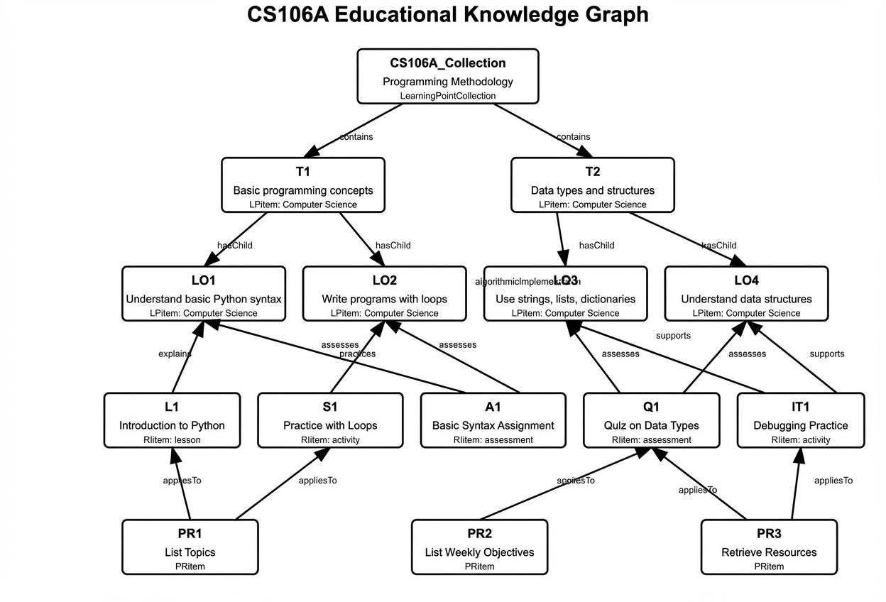
Figure A.1—CS106A Knowledge Graph
The knowledge graph encompasses several key entity types:
- LearningPointCollection: The CS106A Collection serves as the top-level container, representing the entire course. Importantly, this collection only explicitly references the top-level learning points(T1, T2), while lower-level points are implicitly included through hierarchical relationships. This optimizes the graph’s storage requirements while maintaining logical completeness.
- LearningPoints(LPitems): Structured in a hierarchy, with topics (T1: Basic programming concepts, T2: Data types and structures) at the top level and specific learning objectives (LO1-LO4) as children. Each learning point includes a discipline property (“Computer Science”) to enable cross-disciplinary contexts.
- ResourceItems(RItems): Various educational resources including lessons (L1), practice activities(S1, IT1), and assessments (A1, Q1). Each resource connects to specific learning objectives through semantically meaningful relationships.
- PedagogicalRules(PRitems): Rules that guide the educational process (PR1-PR3), such as sequencing content or selecting resources based on the learning context.

Relationship types and semantic connections
The diagram illustrates several types of relationships that provide rich semantic context:
- Structural relationships: contains (collection of topics) and hasChild or hasParent (topics to learning objectives) establish the hierarchical organization.
- Pedagogical relationships: Specific connections between resources and learning objectives, such as explains, practices, assesses, and supports, provide nuanced information about the purpose of each resource.
- Application relationships: This applies to relationship links pedagogical rules to the resources they govern.
- Domain-specific relationships: Custom relationships like algorithmic implementation (shown as a dashed line between LO2 and LO3) enable discipline-specific connections that capture specialized knowledge structures.

From syllabus to knowledge graph
Converting a traditional course syllabus into this knowledge graph structure involves several steps:
- Topic extraction: Identifying main topics and subtopics from the syllabus and course materials.
- Learning objective formulation: Defining specific, measurable learning objectives for each topic.
- Resource classification: Cataloging educational resources and classifying them based on type and purpose.
- Relationship mapping: Establishing connections between learning points and resources with appropriate relationship types.
- Rule definition: Creating pedagogical rules to guide the learning process.
This process can be semi-automated using natural language processing techniques to extract topics and relationships from syllabus documents, followed by expert review and refinement.

Integration with adaptive learning systems
The structured knowledge represented in this graph enables powerful adaptive learning applications. An intelligent teaching assistant built on this foundation could:
- Answer concept questions:
  - By traversing the graph to find relevant learning points and their explanatory resources when students inquire about specific topics.
- Provide targeted resources:
  - Recommend appropriate learning materials based on the specific learning objectives a student is struggling with, using the semantic relationships (explains, practices, etc.) to select the most suitable resources.
- Generate learning paths:
  - Use the hierarchical structure and prerequisite relationships to create personalized learning sequences.
- Assist with assignments:
  - Leverage practices and assess relationships to connect students with the resources most relevant to their current assignments.
- Apply pedagogical strategies:
  - Use the pedagogical rules to adapt teaching approaches based on student progress and learning context.

Implementation example
Consider a student struggling with Python loops (related to LO2). An adaptive learning system could:
- Identify that the student needs help with LO2 (“Write programs with loops”).
- Find resources connected to LO2 via the practices relationship (S1: Practice with Loops).
- Note the assessment A1 connected via assesses to provide practice problems.
- Observe that LO2 has an algorithmic implementation relationship with LO3, suggesting the system could provide real-world data structure examples that use loops.
- Apply pedagogical rule PR1 to structure the presentation of materials.
The extensible nature of this knowledge graph also allows for continuous enrichment. As students interact with the system, their questions, challenges, and learning patterns can be analyzed to add new relationships or refine existing ones, creating an increasingly effective and responsive learning environment.
Through this structure, the knowledge graph bridges the gap between static course materials and dynamic, personalized learning experiences, enabling educational systems that adapt to individual needs while maintaining alignment with curricular goals.

(informative)
EDUKG ontology and sample RDF documents in turtle format

General
This annex provides examples of RDF representations of the EDUKG ontology and several sample knowledge graph implementations from different academic disciplines.

Ontology
@prefix rdf: <http://www.w3.org/1999/02/22-rdf-syntax-ns#> .
@prefix rdfs: <http://www.w3.org/2000/01/rdf-schema#> .
@prefix xsd: <http://www.w3.org/2001/XMLSchema#> .
@prefix owl: <http://www.w3.org/2002/07/owl#> .
@prefix edkg: <http://edkg.org/ontology#> .
@prefix dc: <http://purl.org/dc/elements/1.1/> .
@prefix sh: <http://www.w3.org/ns/shacl#> .
@prefix skos: <http://www.w3.org/2004/02/skos/core#> .

# Ontology Definition
edkg: a owl:Ontology ;
dc:title "Educational Knowledge Graph Ontology" ;
dc:description "An ontology for representing educational entities, learning points, and their relationships in a knowledge graph" ;
owl:versionInfo "1.0.0" ;
dc:creator "EDKG Working Group" ;
dc:date "2024-03-14"^^xsd:date .

#################################################################
# Base Entity Class and Common Properties
#################################################################

edkg:BaseEntity a owl:Class ;
rdfs:label "Base Entity" ;
rdfs:comment "Abstract base class for all EDKG entities" ;
owl:hasKey (edkg:identifier) .

# Required Common Properties
edkg:title a owl:DatatypeProperty ;
rdfs:domain edkg:BaseEntity ;
rdfs:range xsd:string ;
rdfs:label "title" ;
rdfs:comment "Required title for the entity" ;
sh:minCount 1 .

edkg:identifier a owl:DatatypeProperty ;
rdfs:domain edkg:BaseEntity ;
rdfs:range xsd:string ;
rdfs:label "identifier" ;
rdfs:comment "Required GUID identifier" ;
sh:pattern "^[0-9a-fA-F]{8}-[0-9a-fA-F]{4}-[0-9a-fA-F]{4}-[0-9a-fA-F]{4}-[0-9a-fA-F]{12}$" ;
sh:minCount 1 .

edkg:itemType a owl:DatatypeProperty ;
rdfs:domain edkg:BaseEntity ;
rdfs:range edkg:ItemTypeValue ;
rdfs:label "item type" ;
rdfs:comment "Required type classification" ;
sh:minCount 1 .

# Optional Common Properties
edkg:tags a owl:DatatypeProperty ;
rdfs:domain edkg:BaseEntity ;
rdfs:range rdf:List ;
rdfs:label "tags" ;
rdfs:comment "Optional list of tags" .

edkg:humanAssignedId a owl:DatatypeProperty ;
rdfs:domain edkg:BaseEntity ;
rdfs:range xsd:string ;
rdfs:label "human assigned ID" ;
rdfs:comment "Optional human-readable identifier" .

edkg:contentJson a owl:DatatypeProperty ;
rdfs:domain edkg:BaseEntity ;
rdfs:range xsd:string ;
rdfs:label "content JSON" ;
rdfs:comment "Optional JSON content for extended properties" .

edkg:lastChangeDateTime a owl:DatatypeProperty ;
rdfs:domain edkg:BaseEntity ;
rdfs:range xsd:dateTime ;
rdfs:label "last change date time" ;
rdfs:comment "When the entity was last modified" .

#################################################################
# Core Classes
#################################################################

# Learning Point Collection
edkg:LearningPointCollection a owl:Class ;
rdfs:subClassOf edkg:BaseEntity ;
rdfs:label "Learning Point Collection" ;
rdfs:comment "A collection of learning points" .

# Learning Point Item
edkg:LPitem a owl:Class ;
rdfs:subClassOf edkg:BaseEntity ;
rdfs:label "Learning Point" ;
rdfs:comment "An individual learning point" .

# Resource Item
edkg:RIitem a owl:Class ;
rdfs:subClassOf edkg:BaseEntity ;
rdfs:label "Resource Item" ;
rdfs:comment "A resource item" .

# Pedagogical Rule Item
edkg:PRitem a owl:Class ;
rdfs:subClassOf edkg:BaseEntity ;
rdfs:label "Pedagogical Rule" ;
rdfs:comment "A pedagogical rule following KSTAR structure" .

#################################################################
# Collection Management
#################################################################

# Collection Properties
edkg:collectionUri a owl:DatatypeProperty ;
rdfs:domain edkg:LearningPointCollection ;
rdfs:range xsd:anyURI ;
rdfs:label "collection URI" ;
rdfs:comment "Unique URI for the collection" ;
sh:minCount 1 .

edkg:version a owl:DatatypeProperty ;
rdfs:domain edkg:LearningPointCollection ;
rdfs:range xsd:string ;
rdfs:label "version" ;
rdfs:comment "Version identifier of the collection" .

# Collection Dependencies
edkg:CollectionDependency a owl:Class ;
rdfs:label "Collection Dependency" ;
rdfs:comment "Represents a dependency on another collection" .

edkg:hasDependency a owl:ObjectProperty ;
rdfs:domain edkg:LearningPointCollection ;
rdfs:range edkg:CollectionDependency ;
rdfs:label "has dependency" ;
rdfs:comment "Links a collection to its dependencies" .

edkg:dependencyUri a owl:DatatypeProperty ;
rdfs:domain edkg:CollectionDependency ;
rdfs:range xsd:anyURI ;
rdfs:label "dependency URI" ;
sh:minCount 1 .

edkg:dependencyVersion a owl:DatatypeProperty ;
rdfs:domain edkg:CollectionDependency ;
rdfs:range xsd:string .

edkg:dependencyPurpose a owl:DatatypeProperty ;
rdfs:domain edkg:CollectionDependency ;
rdfs:range [
a rdfs:Datatype ;
owl:oneOf ("alignment" "extension" "prerequisite" "reference")
] ;
sh:minCount 1 .

#################################################################
# Learning Point Properties and Relationships
#################################################################

# LP Properties
edkg:fullStatement a owl:DatatypeProperty ;
rdfs:domain edkg:LPitem ;
rdfs:range xsd:string .

edkg:sequenceNumber a owl:DatatypeProperty ;
rdfs:domain edkg:LPitem ;
rdfs:range xsd:integer .

# Tree Structure Properties
edkg:treeLevel a owl:DatatypeProperty ;
rdfs:domain edkg:LPitem ;
rdfs:range xsd:integer .

edkg:treePosition a owl:DatatypeProperty ;
rdfs:domain edkg:LPitem ;
rdfs:range xsd:string .

# New Discipline Property - as a datatype property for learning points
edkg:discipline a owl:DatatypeProperty ;
rdfs:domain edkg:LPitem ;
rdfs:range xsd:string ;
rdfs:label "discipline" ;
rdfs:comment "Academic discipline or field to which this learning point belongs" .

# Internal Relationships
edkg:hasParent a owl:ObjectProperty ;
rdfs:domain edkg:LPitem ;
rdfs:range edkg:LPitem .

edkg:hasChild a owl:ObjectProperty ;
rdfs:domain edkg:LPitem ;
rdfs:range edkg:LPitem ;
owl:inverseOf edkg:hasParent .

# CASE Relationships
edkg:isPrerequisiteFor a owl:ObjectProperty ;
rdfs:subPropertyOf skos:broader ;
rdfs:domain edkg:LPitem ;
rdfs:range edkg:LPitem .

edkg:hasPrerequisite a owl:ObjectProperty ;
rdfs:subPropertyOf skos:narrower ;
rdfs:domain edkg:LPitem ;
rdfs:range edkg:LPitem ;
owl:inverseOf edkg:isPrerequisiteFor .

edkg:isEquivalentTo a owl:ObjectProperty, owl:SymmetricProperty ;
rdfs:subPropertyOf skos:exactMatch ;
rdfs:domain edkg:LPitem ;
rdfs:range edkg:LPitem .

edkg:isBroaderThan a owl:ObjectProperty ;
rdfs:subPropertyOf skos:broader ;
rdfs:domain edkg:LPitem ;
rdfs:range edkg:LPitem .

edkg:isNarrowerThan a owl:ObjectProperty ;
rdfs:subPropertyOf skos:narrower ;
rdfs:domain edkg:LPitem ;
rdfs:range edkg:LPitem ;
owl:inverseOf edkg:isBroaderThan .

edkg:isRelatedTo a owl:ObjectProperty, owl:SymmetricProperty ;
rdfs:subPropertyOf skos:related ;
rdfs:domain edkg:LPitem ;
rdfs:range edkg:LPitem .

#################################################################
# External References
#################################################################

edkg:ExternalReference a owl:Class ;
rdfs:label "External Reference" ;
rdfs:comment "Represents a reference to an item in another collection" .

edkg:hasExternalMatch a owl:ObjectProperty ;
rdfs:domain edkg:LPitem ;
rdfs:range edkg:ExternalReference .

edkg:externalCollectionUri a owl:DatatypeProperty ;
rdfs:domain edkg:ExternalReference ;
rdfs:range xsd:anyURI ;
sh:minCount 1 .

edkg:externalIdentifier a owl:DatatypeProperty ;
rdfs:domain edkg:ExternalReference ;
rdfs:range xsd:string ;
sh:minCount 1 .

#################################################################
# Resource Item Properties and Relationships
#################################################################

edkg:resourceType a owl:DatatypeProperty ;
rdfs:domain edkg:RIitem ;
rdfs:range [
a rdfs:Datatype ;
owl:oneOf (
"assessment"
"lesson"
"activity"
"reference"
"tool"
"media"
"simulation"
"game"
"dataset"
"example"
"template"
"rubric"
)
] .

edkg:resourceUrl a owl:DatatypeProperty ;
rdfs:domain edkg:RIitem ;
rdfs:range xsd:anyURI .

edkg:resourceFormat a owl:DatatypeProperty ;
rdfs:domain edkg:RIitem ;
rdfs:range xsd:string .

#################################################################
# Pedagogical Rule Properties (KSTAR)
#################################################################

edkg:actorRole a owl:DatatypeProperty ;
rdfs:domain edkg:PRitem ;
rdfs:range xsd:string .

edkg:situation a owl:DatatypeProperty ;
rdfs:domain edkg:PRitem ;
rdfs:range xsd:string .

edkg:task a owl:DatatypeProperty ;
rdfs:domain edkg:PRitem ;
rdfs:range xsd:string .

edkg:actionPlan a owl:DatatypeProperty ;
rdfs:domain edkg:PRitem ;
rdfs:range xsd:string .

edkg:expectedResult a owl:DatatypeProperty ;
rdfs:domain edkg:PRitem ;
rdfs:range xsd:string .

#################################################################
# Cross-Entity Relationships
#################################################################

edkg:hasLearningPoint a owl:ObjectProperty ;
rdfs:domain
[
owl:unionOf (edkg:LearningPointCollection edkg:RIitem edkg:PRitem)
] ;
rdfs:range edkg:LPitem .

edkg:hasResource a owl:ObjectProperty ;
rdfs:domain [
owl:unionOf (edkg:LPitem edkg:PRitem)
] ;
rdfs:range edkg:RIitem .

edkg:hasPedagogicalRule a owl:ObjectProperty ;
rdfs:domain [
owl:unionOf (edkg:LPitem edkg:RIitem)
] ;
rdfs:range edkg:PRitem .

edkg:appliesTo a owl:ObjectProperty ;
rdfs:domain edkg:PRitem ;
rdfs:range [
owl:unionOf (edkg:LPitem edkg:RIitem)
] ;
owl:inverseOf edkg:hasPedagogicalRule .

#################################################################
# Disciplinary Properties for Domain-Specific Relationships
#################################################################

edkg:DisciplinaryProperty rdfs:subClassOf owl:ObjectProperty ;
rdfs:domain edkg:LPitem ;
rdfs:range edkg:LPitem ;
rdfs:label "Disciplinary Property" ;
rdfs:comment "Base class for domain-specific relationships between learning points" .

#################################################################
# Standard Relationship Type Properties
#################################################################

# Define specific relationship type properties
edkg:contains a owl:ObjectProperty ;
rdfs:subPropertyOf edkg:hasLearningPoint ;
rdfs:domain [
owl:unionOf (edkg:LearningPointCollection edkg:RIitem edkg:PRitem)
] ;
rdfs:range edkg:LPitem ;
rdfs:label "contains" ;
rdfs:comment "Indicates that one entity contains another as a component" .

edkg:supports a owl:ObjectProperty ;
rdfs:subPropertyOf edkg:hasLearningPoint ;
rdfs:domain [
owl:unionOf (edkg:LearningPointCollection edkg:RIitem edkg:PRitem)
] ;
rdfs:range edkg:LPitem ;
rdfs:label "supports" ;
rdfs:comment "Indicates that one entity provides supporting content for another" .

edkg:implements a owl:ObjectProperty ;
rdfs:subPropertyOf edkg:hasLearningPoint ;
rdfs:domain [
owl:unionOf (edkg:LearningPointCollection edkg:RIitem edkg:PRitem)
] ;
rdfs:range edkg:LPitem ;
rdfs:label "implements" ;
rdfs:comment "Indicates that one entity implements the guidelines of another" .

edkg:demonstrates a owl:ObjectProperty ;
rdfs:subPropertyOf edkg:hasLearningPoint ;
rdfs:domain [
owl:unionOf (edkg:LearningPointCollection edkg:RIitem edkg:PRitem)
] ;
rdfs:range edkg:LPitem ;
rdfs:label "demonstrates" ;
rdfs:comment "Indicates that one entity demonstrates the skills or knowledge of another" .

edkg:explains a owl:ObjectProperty ;
rdfs:subPropertyOf edkg:hasLearningPoint ;
rdfs:domain [
owl:unionOf (edkg:LearningPointCollection edkg:RIitem edkg:PRitem)
] ;
rdfs:range edkg:LPitem ;
rdfs:label "explains" ;
rdfs:comment "Indicates that one entity explains the concepts of another" .

edkg:practices a owl:ObjectProperty ;
rdfs:subPropertyOf edkg:hasLearningPoint ;
rdfs:domain [
owl:unionOf (edkg:LearningPointCollection edkg:RIitem edkg:PRitem)
] ;
rdfs:range edkg:LPitem ;
rdfs:label "practices" ;
rdfs:comment "Indicates that one entity provides practice for another" .

edkg:assesses a owl:ObjectProperty ;
rdfs:subPropertyOf edkg:hasLearningPoint ;
rdfs:domain [
owl:unionOf (edkg:LearningPointCollection edkg:RIitem edkg:PRitem)
] ;
rdfs:range edkg:LPitem ;
rdfs:label "assesses" ;
rdfs:comment "Indicates that one entity assesses the knowledge or skills of another" .

edkg:extends a owl:ObjectProperty ;
rdfs:subPropertyOf edkg:hasLearningPoint ;
rdfs:domain [
owl:unionOf (edkg:LearningPointCollection edkg:RIitem edkg:PRitem)
] ;
rdfs:range edkg:LPitem ;
rdfs:label "extends" ;
rdfs:comment "Indicates that one entity extends the content of another" .

Computer science knowledge graph
@prefix edkg: <http://edkg.org/ontology#> .
@prefix xsd: <http://www.w3.org/2001/XMLSchema#> .
@prefix ex: <http://example.org/instance#> .
@prefix rdf: <http://www.w3.org/1999/02/22-rdf-syntax-ns#> .

########################################
# Learning Point Collection
########################################
ex:CS106A_Collection
a edkg:LearningPointCollection ;
edkg:identifier "937b9561-7184-4aa0-b29e-37322d9b6f9a" ;
edkg:title "Programming Methodology" ;
edkg:humanAssignedId "CS106A_Collection" ;
edkg:collectionUri "http://example.org/cs106a/collection" ;
edkg:version "1.0.0" ;
edkg:contains ex:T1, ex:T2 . # Only top-level topics
########################################
# Learning Points
########################################
ex:T1
a edkg:LPitem ;
edkg:identifier "f30802c6-78bf-411f-83ad-6d6b3b5d6c33" ;
edkg:title "Basic programming concepts" ;
edkg:itemType "Topic" ;
edkg:discipline "Computer Science" ;
edkg:fullStatement "Covers basic Python syntax, control flow, and foundational programming ideas." ;
edkg:hasChild ex:LO1, ex:LO2 ;
edkg:treeLevel 1 ;
edkg:treePosition "1" ;
edkg:humanAssignedId "T1" .

ex:T2
a edkg:LPitem ;
edkg:identifier "ab3c5113-289f-4a21-9ac5-8c752da19238" ;
edkg:title "Data types and structures" ;
edkg:itemType "Topic" ;
edkg:discipline "Computer Science" ;
edkg:fullStatement "Covers strings, lists, dictionaries, and how data structures store/manipulate data." ;
edkg:hasChild ex:LO3, ex:LO4 ;
edkg:treeLevel 1 ;
edkg:treePosition "2" ;
edkg:humanAssignedId "T2" .

ex:LO1
a edkg:LPitem ;
edkg:identifier "24bc0a5a-438e-4c7c-aec8-a8ca50a41d8a" ;
edkg:title "Understand basic Python syntax" ;
edkg:itemType "LearningObjective" ;
edkg:discipline "Computer Science" ;
edkg:fullStatement "Able to read and interpret simple Python statements." ;
edkg:hasParent ex:T1 ;
edkg:treeLevel 2 ;
edkg:treePosition "1.1" ;
edkg:humanAssignedId "LO1" .

ex:LO2
a edkg:LPitem ;
edkg:identifier "19396c62-0517-4a8a-914a-22c376de4b7e" ;
edkg:title "Write simple programs using loops and conditionals" ;
edkg:itemType "LearningObjective" ;
edkg:discipline "Computer Science" ;
edkg:fullStatement "Able to use for/while loops and if-statements in Python to create small programs." ;
edkg:hasParent ex:T1 ;
edkg:treeLevel 2 ;
edkg:treePosition "1.2" ;
edkg:humanAssignedId "LO2" .

ex:LO3
a edkg:LPitem ;
edkg:identifier "7eae72c5-c67b-4819-bde9-c50e3ca93944" ;
edkg:title "Use strings, lists, and dictionaries in Python" ;
edkg:itemType "LearningObjective" ;
edkg:discipline "Computer Science" ;
edkg:fullStatement "Able to implement Python code that manipulates text, collections, and key-value pairs." ;
edkg:hasParent ex:T2 ;
edkg:treeLevel 2 ;
edkg:treePosition "2.1" ;
edkg:humanAssignedId "LO3" .

ex:LO4
a edkg:LPitem ;
edkg:identifier "d5c8441b-27d3-410f-9d1d-b32b3acfdcaa" ;
edkg:title "Understand how data structures store and manipulate data" ;
edkg:itemType "LearningObjective" ;
edkg:discipline "Computer Science" ;
edkg:fullStatement "Able to describe the basic principles of data organization in Python." ;
edkg:hasParent ex:T2 ;
edkg:treeLevel 2 ;
edkg:treePosition "2.2" ;
edkg:humanAssignedId "LO4" .

########################################
# Resource Items
########################################
ex:L1
a edkg:RIitem ;
edkg:identifier "c72851f7-3f79-4cdf-964d-df15ff35b9fc" ;
edkg:title "Introduction to Python" ;
edkg:itemType "Resource" ;
edkg:resourceType "lesson" ;
edkg:resourceUrl "http://example.org/lecture/intro-python" ;
edkg:resourceFormat "video" ;
edkg:explains ex:LO1 ;
edkg:hasPedagogicalRule ex:PR1 ;
edkg:humanAssignedId "L1" .

ex:S1
a edkg:RIitem ;
edkg:identifier "f956b981-0dfd-4a52-a217-927b89bbfef8" ;
edkg:title "Practice with Loops and Conditionals" ;
edkg:itemType "Resource" ;
edkg:resourceType "activity" ;
edkg:resourceUrl "http://example.org/section/loops-conditionals" ;
edkg:resourceFormat "text/html" ;
edkg:practices ex:LO2 ;
edkg:hasPedagogicalRule ex:PR1 ;
edkg:humanAssignedId "S1" .

ex:A1
a edkg:RIitem ;
edkg:identifier "a218d85f-8127-40ce-a954-63d1cc1b39ac" ;
edkg:title "Basic Syntax Assignment" ;
edkg:itemType "Resource" ;
edkg:resourceType "assessment" ;
edkg:resourceUrl "http://example.org/assignment/basic-syntax" ;
edkg:resourceFormat "text/html" ;
edkg:assesses ex:LO1, ex:LO2 ;
edkg:humanAssignedId "A1" .

ex:Q1
a edkg:RIitem ;
edkg:identifier "84937c2e-9a54-4db7-b997-77abe8d0218f" ;
edkg:title "Quiz on Data Types" ;
edkg:itemType "Resource" ;
edkg:resourceType "assessment" ;
edkg:resourceUrl "http://example.org/quiz/data-types" ;
edkg:resourceFormat "text/html" ;
edkg:assesses ex:LO3, ex:LO4 ;
edkg:hasPedagogicalRule ex:PR2, ex:PR3 ;
edkg:humanAssignedId "Q1" .

ex:IT1
a edkg:RIitem ;
edkg:identifier "d1159303-97b4-4a46-a67e-365bd20a72fb" ;
edkg:title "Debugging Practice" ;
edkg:itemType "Resource" ;
edkg:resourceType "activity" ;
edkg:resourceUrl "http://example.org/interactive/debug" ;
edkg:resourceFormat "text/html" ;
edkg:supports ex:LO3, ex:LO4 ;
edkg:hasPedagogicalRule ex:PR3 ;
edkg:humanAssignedId "IT1" .

########################################
# Pedagogical Rules
########################################
ex:PR1
a edkg:PRitem ;
edkg:identifier "90f0b8ec-2b70-4adf-a999-8ff2e55bc798" ;
edkg:title "List Topics" ;
edkg:situation """
When starting the course, the system identifies and lists all available topics.
""" ;
edkg:task """
Retrieve all topics from the Learning Points hierarchy.
""" ;
edkg:actionPlan """
Access the Learning Points collection and extract all associated topics.
""" ;
edkg:expectedResult """
A comprehensive list of topics covered in the course.
""" ;
edkg:actorRole "LMSAssistant" ;
edkg:appliesTo ex:L1, ex:S1 ;
edkg:humanAssignedId "PR1" .

ex:PR2
a edkg:PRitem ;
edkg:identifier "d67a231e-4cdc-4629-aa53-8e3af44767ce" ;
edkg:title "List Weekly Objectives" ;
edkg:situation """
When a week is selected, the system identifies the learning objectives for that week.
""" ;
edkg:task """
Extract objectives from the Sequence hierarchy for the given week.
""" ;
edkg:actionPlan """
Access the Sequence hierarchy and extract objectives for the given week.
""" ;
edkg:expectedResult """
A detailed list of learning objectives for the specified week.
""" ;
edkg:actorRole "LMSAssistant" ;
edkg:appliesTo ex:Q1 ;
edkg:humanAssignedId "PR2" .

ex:PR3
a edkg:PRitem ;
edkg:identifier "54b9be2d-6fd6-412d-a021-036e09e487c4" ;
edkg:title "Retrieve Resources" ;
edkg:situation """
When locating resources, the system filters and retrieves items by type and week.
""" ;
edkg:task """
Navigate the Resource Construct hierarchy and filter by resource type and week.
""" ;
edkg:actionPlan """
Access the Resource Construct hierarchy and filter based on ResourceType and WeekNumber.
""" ;
edkg:expectedResult """
A list of resources categorized by type and purpose.
""" ;
edkg:actorRole "LMSAssistant" ;
edkg:appliesTo ex:Q1, ex:IT1 ;
edkg:humanAssignedId "PR3" .

########################################
# Example of Custom Disciplinary Properties
########################################
# Define a computer science specific relationship
ex:algorithmicImplementation a edkg:DisciplinaryProperty ;
rdfs:label "algorithmic implementation" ;
rdfs:comment "Relationship describing how algorithms are implemented in programming" .

# Use the custom relationship
ex:LO2 ex:algorithmicImplementation ex:LO3 .

Physics knowledge graph
The example of a physical graph is constructed from university physics textbooks, with excerpts from two sections: "Discovery of Particles" and "Classification of Particles". This graph example focuses on demonstrating how to use the attributes and relationships of the LearningPoint entity class in the ontology for knowledge expression. It covers key attributes such as the hierarchy of LearningPoint (hasChild, treeLevel, treePosition) and knowledge content (contentJson). It also illustrates how to use DisciplinaryProperty to describe domain-specific relationships between LearningPoints.
@prefix edkg: <http://edkg.org/ontology#> .
@prefix lp: <https://kgeditor.cn/physics_example/lp/> .
@prefix r: <https://kgeditor.cn/physics_example/relation/> .

########################################
# Learning Point Collection
########################################

lp:PhysicsExample_Collection a edkg:LearningPointCollection;
edkg:identifier "234d22c8-9958-4789-bb36-673f32cc38ac";
edkg:title "Physics" ;
edkg:version: "1.0.0" ;
edkg:contains lp:1_ElementaryParticle ;

########################################
# Declaration of Customized Disciplinary Properties
########################################

r:includes a edkg:DisciplinaryProperty .

r:decaysInto a edkg:DisciplinaryProperty .

r:emits a edkg:DisciplinaryProperty .

r:isComposedOf a edkg:DisciplinaryProperty .

r:transformsInto a edkg:DisciplinaryProperty .

########################################
# Learning Points
########################################

lp:1_ElementaryParticle a edkg:LPitem ;
edkg:hasChild lp:1_1_DiscoveryOfParticles,
lp:1_2_ClassificationOfParticles ;
edkg:identifier "cfd495bc-acb7-46f4-81f1-41597c2a8635" ;
edkg:itemType "KUnit" ;
edkg:title "1_ElementaryParticle" ;
edkg:treeLevel 1 ;
edkg:treePosition "1" .

lp:1_1_DiscoveryOfParticles a edkg:LPitem ;
edkg:hasChild lp:elementary_charge_e,
lp:atom,
lp:elementary_particle,
lp:particle,
lp:spin_quantization,
lp:particle_lifetime,
lp:mass-energy_equivalence,
lp:electric_charge,
lp:positron ;
edkg:identifier "80937968-23b7-472e-b6b4-acf316b24ee0" ;
edkg:itemType "KUnit" ;
edkg:title "1_1_DiscoveryOfParticles" ;
edkg:treeLevel 2 ;
edkg:treePosition "1.1" .

lp:1_2_ClassificationOfParticles a edkg:LPitem ;
edkg:hasChild lp:fundamental_interactions,
lp:hadron,
lp:proton,
lp:u-quark,
lp:d-quark,
lp:neutron,
lp:meson,
lp:neutrino ;
edkg:identifier "ea59c1a5-f963-4fb4-b6f7-eccaa4c4b358" ;
edkg:itemType "KUnit" ;
edkg:title "1_2_ClassificationOfParticles" ;
edkg:treeLevel 2 ;
edkg:treePosition "1.2" .

# Sub Learning Point of 1_1

lp:elementary_charge_e a edkg:LPitem ;
edkg:contentJson "{\"value\": \"1.602 * 10^-19 C\"}" ;
edkg:identifier "750efecf-46b7-4d6c-84fd-3e221e75bf03" ;
edkg:itemType "KPoint" ;
edkg:title "elementary_charge_e" ;
edkg:treeLevel 3 ;
edkg:treePosition "1.1.1" .

lp:atom a edkg:LPitem ;
edkg:contentJson "{\"composition\": \"electron, atomic nucleus\"}" ;
edkg:identifier "e678beae-2299-47b1-8c0e-6d4fbc173da3" ;
edkg:itemType "KPoint" ;
edkg:title "atom" ;
edkg:treeLevel 3 ;
edkg:treePosition "1.1.2" .

lp:elementary_particle a edkg:LPitem ;
edkg:contentJson "{\"definition\": \"Particles with different masses and properties that can transform into each other\"}" ;
edkg:identifier "c91fed72-cb50-43da-8cc9-143d1ea8d943" ;
edkg:itemType "KPoint" ;
edkg:title "elementary_particle" ;
edkg:treeLevel 3 ;
edkg:treePosition "1.1.3" .

lp:particle a edkg:LPitem ;
edkg:contentJson "{\"electric charge\": \"positive, negative, neutral\"}" ;
edkg:identifier "fd340149-b9ea-49c1-add5-f10e1d1d49c1" ;
edkg:itemType "KPoint" ;
edkg:title "particle" ;
r:includes lp:lifetime,
lp:spin_motion ;
r:decaysInto lp:particle ;
edkg:treeLevel 3 ;
edkg:treePosition "1.1.4" .

lp:spin_quantization a edkg:LPitem ;
edkg:contentJson "{\"description\": \"The spin angular momentum (or spin) of each particle is also quantized, usually measured in multiples of Planck's constant\"}" ;
edkg:identifier "8845cf46-b9d9-41b1-92f4-1dcdef2017d8" ;
edkg:itemType "KPoint" ;
edkg:title "spin_quantization" ;
edkg:treeLevel 3 ;
edkg:treePosition "1.1.5" .

lp:particle_lifetime a edkg:LPitem ;
edkg:contentJson "{\"definition\": \"The average time a particle exists before decaying is called its lifetime\"}" ;
edkg:identifier "f605007b-eb1a-47f5-924a-e880e0bbcd0b" ;
edkg:itemType "KPoint" ;
edkg:title "particle_lifetime" ;
edkg:treeLevel 3 ;
edkg:treePosition "1.1.6" .

lp:mass-energy_equivalence a edkg:LPitem ;
edkg:contentJson "{\"formula\": \"E=mc^2\", \"proposed by\": \"Einstein\"}" ;
edkg:identifier "835fe351-2f4e-441a-9f15-e8f2f6e24fb5" ;
edkg:itemType "KPoint" ;
edkg:title "mass-energy_equivalence" ;
edkg:treeLevel 3 ;
edkg:treePosition "1.1.7" .

lp:electric_charge a edkg:LPitem ;
edkg:identifier "1da6c439-3e9e-4f79-b1d2-a9c7ce17c7f7" ;
edkg:itemType "KPoint" ;
edkg:title "electric_charge" ;
r:includes lp:elementary_charge_e ;
edkg:treeLevel 3 ;
edkg:treePosition "1.1.8" .

lp:positron a edkg:LPitem ;
edkg:identifier "7b3a04ec-c405-4fb7-be44-a7b0b1eb13f8" ;
edkg:itemType "KPoint" ;
edkg:title "positron" ;
edkg:treeLevel 3 ;
edkg:treePosition "1.1.9" .

# Sub Learning Point of 1_2

lp:fundamental_interactions a edkg:LPitem ;
edkg:contentJson "{\"number\": \"4 types\", \"classification\": \"['gravity', 'electromagnetic force', 'strong interaction', 'weak interaction']\"}" ;
edkg:identifier "64128038-565c-47bf-a1e0-357783a94264" ;
edkg:itemType "KPoint" ;
edkg:title "fundamental_interactions" ;
edkg:treeLevel 3 ;
edkg:treePosition "1.2.1" .

lp:hadron a edkg:LPitem ;
edkg:contentJson "{\"characteristic physical quantities\": \"particle type, spin, mass, electric charge\"}" ;
edkg:identifier "f995cd2e-c4fa-4689-bfe8-0332d73e17ca" ;
edkg:itemType "KPoint" ;
edkg:title "hadron" ;
edkg:treeLevel 3 ;
edkg:treePosition "1.2.2" .

lp:proton a edkg:LPitem ;
edkg:contentJson "{\"composition\": \"2 up quarks and 1 down quark\"}" ;
edkg:identifier "c57ef85f-4a69-498a-a5b7-0409816b2c5f" ;
edkg:itemType "KPoint" ;
edkg:title "proton" ;
r:emits lp:neutrino,
lp:positron ;
r:isComposedOf lp:u-quark,
lp:d-quark;
r:transformsInto lp:neutron,
lp:meson ;
edkg:treeLevel 3 ;
edkg:treePosition "1.2.3" .

lp:u-quark a edkg:LPitem ;
edkg:identifier "5827f33e-c620-42a5-afbc-5e8a1e939693" ;
edkg:itemType "KPoint" ;
edkg:title "u-quark" ;
edkg:treeLevel 3 ;
edkg:treePosition "1.2.4" .

lp:d-quark a edkg:LPitem ;
edkg:identifier "95e87536-7620-46b7-998f-89e24a90a748" ;
edkg:itemType "KPoint" ;
edkg:title "d-quark" ;
edkg:treeLevel 3 ;
edkg:treePosition "1.2.5" .

lp:neutron a edkg:LPitem ;
edkg:contentJson "{\"composition\": \"2 down quarks and 1 up quark\"}" ;
edkg:identifier "820ce5f1-2cd1-45d0-9a45-706ee4521c2d" ;
edkg:itemType "KPoint" ;
edkg:title "neutron" ;
r:isComposedOf lp:u-quark,
lp:d-quark ;
edkg:treeLevel 3 ;
edkg:treePosition "1.2.6" .

lp:meson a edkg:LPitem ;
edkg:identifier "c259434c-4a20-449d-b323-9ac303fa8342" ;
edkg:itemType "KPoint" ;
edkg:title "meson" ;
edkg:treeLevel 3 ;
edkg:treePosition "1.2.7" .

lp:neutrino a edkg:LPitem ;
edkg:identifier "9d048519-0290-43f6-ac06-2265ec9dda86" ;
edkg:itemType "KPoint" ;
edkg:title "neutrino" ;
edkg:treeLevel 3 ;
edkg:treePosition "1.2.8" .

Biology knowledge graph
This case describes a biology learning point collection (Bio701_Collection) based on the Educational Knowledge Graph (EDKG). This collection is used to organize and manage knowledge points related to “Biology” in primary and secondary education, using the Turtle (TTL) format for structured representation.
Bio701_Collection is constructed by an educational knowledge graph system from teaching resources of different sources and formats to build a high-precision, standardized biology knowledge graph. This graph example focuses on demonstrating how to use the attributes and relationships of the LearningPoint entity class in the ontology for knowledge representation. It covers key attributes such as the hierarchical structure of LearningPoint (hasChild, treeLevel) and knowledge content (fullStatement). Additionally, it illustrates how to use topic classification (itemType) to describe the category of learning points and their interrelations.
The graph includes multiple specific learning points, each with a unique identifier, title, hierarchical structure, and detailed description. For example, one of the learning points (T1) is titled “Biology and Cells,” categorized as a “Topic.” It covers content such as "observing living organisms in the surrounding environment" and "characteristics of living organisms.” This topic also contains multiple sub-learning points (LO1, LO2) to further refine the knowledge.
This case demonstrates how educational knowledge graphs can systematically organize subject knowledge and achieve structured organization through hierarchical structures and relationships. This approach can be applied to intelligent education systems to support personalized learning, knowledge recommendation, and automated assessment.
@prefix edkg: <http://edkg.org/ontology#> .
@prefix xsd: <http://www.w3.org/2001/XMLSchema#> .
@prefix ex: <http://example.org/instance#> .
@prefix rdf: <http://www.w3.org/1999/02/22-rdf-syntax-ns#> .

########################################
# Learning Point Collection
########################################
ex:Bio701_Collection
a edkg:LearningPointCollection ;
edkg:identifier "937b9561-7184-4aa0-b29e-37322d9b6f9a" ;
edkg:title "Biology" ;
edkg:humanAssignedId "Bio701_Collection" ;
edkg:collectionUri "https://basic.smartedu.cn" ;
edkg:version "1.0.0" ;
edkg:hasLearningPoint ex:T1, ex:T2, ex:LO1, ex:LO2, ex:LO3, ex:LO4 .

########################################
# Learning Points
########################################
ex:T1
a edkg:LPitem ;
edkg:identifier "f30802c6-78bf-411f-83ad-6d6b3b5d6c33" ;
edkg:title "Biology and Cells" ;
edkg:itemType "Topic" ;
edkg:fullStatement "Covers Observe living organisms in the surrounding environment and Characteristics of living organisms." ;
edkg:hasChild ex:LO1, ex:LO2 ;
edkg:treeLevel 1 ;
edkg:treePosition "1" ;
edkg:humanAssignedId "T1" .

ex:T2
a edkg:LPitem ;
edkg:identifier "ab3c5113-289f-4a21-9ac5-8c752da19238" ;
edkg:title "Diversity of Living Organisms" ;
edkg:itemType "Topic" ;
edkg:fullStatement "Covers Algae, mosses, ferns and Seed plants." ;
edkg:hasChild ex:LO3, ex:LO4 ;
edkg:treeLevel 1 ;
edkg:treePosition "2" ;
edkg:humanAssignedId "T2" .

ex:LO1
a edkg:LPitem ;
edkg:identifier "24bc0a5a-438e-4c7c-aec8-a8ca50a41d8a" ;
edkg:title "Observe living organisms in the surrounding environment" ;
edkg:itemType "LearningObjective" ;
edkg:fullStatement "Master basic observation methods and record the characteristics of nearby living organisms." ;
edkg:hasParent ex:T1 ;
edkg:treeLevel 2 ;
edkg:treePosition "1.1" ;
edkg:humanAssignedId "LO1" .

ex:LO2
a edkg:LPitem ;
edkg:identifier "19396c62-0517-4a8a-914a-22c376de4b7e" ;
edkg:title "Characteristics of living organisms" ;
edkg:itemType "LearningObjective" ;
edkg:fullStatement "Compare and analyze textual and visual materials of animals and plants, distinguish between living and non-living things, and master the common characteristics of living organisms." ;
edkg:hasParent ex:T1 ;
edkg:treeLevel 2 ;
edkg:treePosition "1.2" ;
edkg:humanAssignedId "LO2" .

ex:LO3
a edkg:LPitem ;
edkg:identifier "7eae72c5-c67b-4819-bde9-c50e3ca93944" ;
edkg:title "Algae, mosses, and ferns" ;
edkg:itemType "LearningObjective" ;
edkg:fullStatement "Be able to analyze the characteristics of algae and mosses that help them adapt to their living environments and understand that the characteristics of living organisms are adapted to their environments." ;
edkg:hasParent ex:T2 ;
edkg:treeLevel 2 ;
edkg:treePosition "2.1" ;
edkg:humanAssignedId "LO3" .

ex:LO4
a edkg:LPitem ;
edkg:identifier "d5c8441b-27d3-410f-9d1d-b32b3acfdcaa" ;
edkg:title "Seed plants" ;
edkg:itemType "LearningObjective" ;
edkg:fullStatement "Master the basic structure of seeds by comparing the similarities and differences in the structures of different seeds." ;
edkg:hasParent ex:T2 ;
edkg:treeLevel 2 ;
edkg:treePosition "2.2" ;
edkg:humanAssignedId "LO4" .

########################################
# Resource Items
########################################
ex:L1
a edkg:RIitem ;
edkg:identifier "c72851f7-3f79-4cdf-964d-df15ff35b9fc" ;
edkg:title "Video on living organisms in the environment" ;
edkg:itemType "Resource" ;
edkg:resourceType "lesson" ;
edkg:resourceUrl "https://www.bilibili.com/video/BV1edweenEHW" ;
edkg:resourceFormat "video" ;
edkg:hasLearningPoint ex:LO1 ;
edkg:hasPedagogicalRule ex:PR1 ;
edkg:humanAssignedId "L1" .

ex:S1
a edkg:RIitem ;
edkg:identifier "f956b981-0dfd-4a52-a217-927b89bbfef8" ;
edkg:title "Distinguishing between living and non-living things" ;
edkg:itemType "Resource" ;
edkg:resourceType "activity" ;
edkg:resourceUrl "https://zy.21cnjy.com/21934485" ;
edkg:resourceFormat "text/html" ;
edkg:hasLearningPoint ex:LO2 ;
edkg:hasPedagogicalRule ex:PR1 ;
edkg:humanAssignedId "S1" .

ex:A1
a edkg:RIitem ;
edkg:identifier "a218d85f-8127-40ce-a954-63d1cc1b39ac" ;
edkg:title "Assignment on the characteristics of living organisms." ;
edkg:itemType "Resource" ;
edkg:resourceType "assessment" ;
edkg:resourceUrl "https://zy.21cnjy.com/21934485" ;
edkg:resourceFormat "text/html" ;
edkg:hasLearningPoint ex:LO1, ex:LO2 ;
edkg:humanAssignedId "A1" .

ex:Q1
a edkg:RIitem ;
edkg:identifier "84937c2e-9a54-4db7-b997-77abe8d0218f" ;
edkg:title "Differentiation of plant characteristics" ;
edkg:itemType "Resource" ;
edkg:resourceType "assessment" ;
edkg:resourceUrl "https://zy.21cnjy.com/21934485" ;
edkg:resourceFormat "text/html" ;
edkg:hasLearningPoint ex:LO3, ex:LO4 ;
edkg:hasPedagogicalRule ex:PR2, ex:PR3 ;
edkg:humanAssignedId "Q1" .

ex:IT1
a edkg:RIitem ;
edkg:identifier "d1159303-97b4-4a46-a67e-365bd20a72fb" ;
edkg:title "Reinforcement exercise on plant characteristic differentiation" ;
edkg:itemType "Resource" ;
edkg:resourceType "activity" ;
edkg:resourceUrl "https://zy.21cnjy.com/21934485" ;
edkg:resourceFormat "text/html" ;
edkg:hasLearningPoint ex:LO3, ex:LO4 ;
edkg:hasPedagogicalRule ex:PR3 ;
edkg:humanAssignedId "IT1" .

########################################
# Pedagogical Rules
########################################
ex:PR1
a edkg:PRitem ;
edkg:identifier "90f0b8ec-2b70-4adf-a999-8ff2e55bc798" ;
edkg:title "Utilize Teaching Resources" ;
edkg:situation """
When preparing for a lesson, the teacher gathers and organizes relevant teaching materials, including textbooks, videos, and exercises.
""" ;
edkg:task """
Identify and collect available resources such as textbooks, multimedia materials, and past test papers related to the lesson topic.
""" ;
edkg:actionPlan """
Review the textbook for key concepts, select relevant educational videos to enhance understanding, and prepare exercises or test questions from past exams to reinforce learning.
""" ;
edkg:expectedResult """
A well-structured lesson plan incorporating diverse teaching resources to support student comprehension and engagement.
""" ;
edkg:actorRole "Teacher" ;
edkg:appliesTo ex:L1, ex:S1 ;
edkg:humanAssignedId "PR1" .

ex:PR2
a edkg:PRitem ;
edkg:identifier "d67a231e-4cdc-4629-aa53-8e3af44767ce" ;
edkg:title "Summarize Key Knowledge Points" ;
edkg:situation """
At the end of a lesson, the teacher summarizes key biological concepts to reinforce student understanding.
""" ;
edkg:task """
Identify the main knowledge points covered in the lesson and present them in a structured summary.
""" ;
edkg:actionPlan """
Review the lesson's key topics, highlight core biological principles, and create summary notes or concept maps for students. Engage students in discussions or quick quizzes to reinforce retention.
""" ;
edkg:expectedResult """
A concise and clear summary of the lesson's key knowledge points, aiding student comprehension and recall.
""" ;
edkg:actorRole "Teacher" ;
edkg:appliesTo ex:Q1 ;
edkg:humanAssignedId "PR2" .

Computer network
@prefix edkg: <http://edkg.org/ontology#> .
@prefix lp: <https://example.com/concept_graph/lp/> .
@prefix r: <https://example.com/concept_graph/relation/> .

########################################
# Declaration of Customized Disciplinary Properties
########################################

r:belong_to a edkg:DisciplinaryProperty .

r:depends_on a edkg:DisciplinaryProperty .

r:layer_below a edkg:DisciplinaryProperty .

r:part_of a edkg:DisciplinaryProperty .

r:synonym_of a edkg:DisciplinaryProperty .

########################################
# Learning Points
########################################

lp:FTP a edkg:LPitem ;
edkg:identifier "964a69ac-7f63-4ab8-8142-a6be90578447" ;
edkg:title "FTP" ;
r:belong_to lp:application_layer_protocol,
<https://example.com/concept_graph/lp/client/server_model> ;
r:depends_on lp:TCP .

lp:IMAP a edkg:LPitem ;
edkg:identifier "a24276c0-ed1d-4839-ba48-6ea1c2d34db1" ;
edkg:title "IMAP" ;
r:belong_to lp:application_layer_protocol,
lp:mail_access_protocol ;
r:depends_on lp:TCP .

lp:POP3 a edkg:LPitem ;
edkg:identifier "a10eccef-326e-464b-9b5c-651510b2e61c" ;
edkg:title "POP3" ;
r:belong_to lp:application_layer_protocol,
lp:mail_access_protocol ;
r:depends_on lp:TCP .

lp:SMTP a edkg:LPitem ;
edkg:identifier "eb822cd0-8f99-463b-93df-02ce86c8b848" ;
edkg:title "SMTP" ;
r:belong_to lp:application_layer_protocol,
<https://example.com/concept_graph/lp/client/server_model> ;
r:depends_on lp:MIME,
lp:TCP .

lp:authoritative_DNS_server a edkg:LPitem ;
edkg:identifier "3e2a67a7-3e82-48be-9cbc-4ade6b21ab4e" ;
edkg:title "authoritative DNS server" ;
r:belong_to lp:DNS_server ;
r:layer_below lp:TLD_DNS_server ;
r:part_of lp:DNS .

lp:instant_messaging a edkg:LPitem ;
edkg:identifier "f2216990-a6db-4d88-892b-10c98157b71d" ;
edkg:title "instant messaging" ;
r:belong_to lp:hybrid_of_client-server_and_P2P .

lp:local_DNS_server a edkg:LPitem ;
edkg:identifier "f2fd0e76-8a60-40fc-8c43-5f2070094fa9" ;
edkg:title "local DNS server" ;
r:belong_to lp:DNS_server ;
r:depends_on lp:dynamic_host_configuration_protocol ;
r:part_of lp:DNS ;
r:synonym_of lp:default_DNS_server .

lp:skype a edkg:LPitem ;
edkg:identifier "e5d5aa77-dd46-4249-a69e-1d44d1a22786" ;
edkg:title "skype" ;
r:belong_to lp:hybrid_of_client-server_and_P2P .

lp:socket a edkg:LPitem ;
edkg:identifier "895c810a-d9eb-44fa-9013-dadb03e4ed6c" ;
edkg:title "socket" ;
r:belong_to lp:application_programming_interface_ ;
r:depends_on lp:distributed_system ;
r:part_of lp:socket_API_primitive .

lp:upper_layer_data a edkg:LPitem ;
edkg:identifier "cbe59fe3-8f67-456c-9254-8645a5b8a490" ;
edkg:title "upper layer data" ;
r:part_of lp:packet .

lp:DNS_resource_record a edkg:LPitem ;
edkg:identifier "4ebccf1c-c74c-4bde-bd53-15bdd7ea0d48" ;
edkg:title "DNS resource record" .

lp:IP_address_allocation a edkg:LPitem ;
edkg:identifier "38f94b1b-72da-4b7e-93b7-1dd1f9096c42" ;
edkg:title "IP address allocation" .

lp:MIME a edkg:LPitem ;
edkg:identifier "b26d2d98-3567-4176-961f-d922dca8b753" ;
edkg:title "MIME" ;
r:belong_to lp:application_layer_protocol .

lp:Peer-to-Peer_model a edkg:LPitem ;
edkg:identifier "26d6a328-6080-4258-af67-99fafdefe49d" ;
edkg:title "Peer-to-Peer model" .

lp:TLD_DNS_server a edkg:LPitem ;
edkg:identifier "f332515c-b354-4e37-96bd-76e9505ae763" ;
edkg:title "TLD DNS server" ;
r:belong_to lp:DNS_server ;
r:layer_below lp:root_DNS_server ;
r:part_of lp:DNS .

lp:UDP a edkg:LPitem ;
edkg:identifier "6f92e096-57a3-4cdf-ba52-95788b1f99f4" ;
edkg:title "UDP" .

lp:URL a edkg:LPitem ;
edkg:identifier "1aa3e21d-846b-4d82-9a57-d5b8d2994806" ;
edkg:title "URL" .

lp:application_programming_interface_ a edkg:LPitem ;
edkg:identifier "b6ca6b30-2887-47a7-8b96-af052bed78aa" ;
edkg:title "application programming interface " .

lp:default_DNS_server a edkg:LPitem ;
edkg:identifier "878b8df0-7a6f-4769-ba4a-16a8215c2f8f" ;
edkg:title "default DNS server" .

lp:distributed_system a edkg:LPitem ;
edkg:identifier "b9fc3464-f0e5-447d-b050-c920913bb752" ;
edkg:title "distributed system" .

lp:domain_name a edkg:LPitem ;
edkg:identifier "f2ad74c7-5dd8-49e1-9592-871779743bcc" ;
edkg:title "domain name" ;
r:part_of lp:URL .

lp:dynamic_host_configuration_protocol a edkg:LPitem ;
edkg:identifier "29206af1-d9ee-4b5b-80c0-aa9717bbfab7" ;
edkg:title "dynamic host configuration protocol" ;
r:depends_on lp:IP_address_allocation .

lp:packet a edkg:LPitem ;
edkg:identifier "15f735db-352a-4e00-9016-9e55998abf84" ;
edkg:title "packet" .

lp:root_DNS_server a edkg:LPitem ;
edkg:identifier "8c216209-2e65-4436-8da6-ede819dc05d9" ;
edkg:title "root DNS server" .

lp:socket_API_primitive a edkg:LPitem ;
edkg:identifier "5414b6ac-a068-4ca9-b1d6-4635fad9e5cc" ;
edkg:title "socket API primitive" .

lp:hybrid_of_client-server_and_P2P a edkg:LPitem ;
edkg:identifier "d747d897-67ff-4ba9-aa57-7b3a82f07475" ;
edkg:title "hybrid of client-server and P2P" ;
r:depends_on lp:Peer-to-Peer_model,
<https://example.com/concept_graph/lp/client/server_model> .

lp:mail_access_protocol a edkg:LPitem ;
edkg:identifier "f220fa93-e0db-4651-8c6c-9f3ff480813e" ;
edkg:title "mail access protocol" .

lp:DNS a edkg:LPitem ;
edkg:identifier "f2202b6e-6bbb-4c90-9e28-b447ab23bba3" ;
edkg:title "DNS" ;
r:belong_to lp:application_layer_protocol,
<https://example.com/concept_graph/lp/client/server_model> ;
r:depends_on lp:DNS_resource_record,
lp:DNS_server,
lp:UDP,
lp:domain_name .

lp:DNS_server a edkg:LPitem ;
edkg:identifier "603941d3-31d5-477d-a27f-cb72646140f8" ;
edkg:title "DNS server" .

lp:TCP a edkg:LPitem ;
edkg:identifier "f80e27b7-ece4-4769-9e48-9a2dd5657e5e" ;
edkg:title "TCP" .

<https://example.com/concept_graph/lp/client/server_model> a edkg:LPitem ;
edkg:identifier "4bbd9999-c28e-485d-92f7-aa2788d743de" ;
edkg:title "client/server model" .

lp:application_layer_protocol a edkg:LPitem ;
edkg:identifier "8def6b20-1265-49d7-beef-ab508fe5c915" ;
edkg:title "application layer protocol" .

Chemistry knowledge graph
The chemistry graph example is excerpted from a subject knowledge graph system for K12 education, focusing on middle school chemistry. It covers core modules such as chemical substances and health, common synthetic materials, and resources related to these learning points. Through the integration of learning and practice with cognitive diagnosis, this graph can be used to construct a data-driven personalized and precise learning support system. It supports adaptive learning engines and knowledge topology inference algorithms, providing intelligent empowerment for subject knowledge services in various scenarios.
@prefix edkg: <http://edkg.org/ontology#> .
@prefix xsd: <http://www.w3.org/2001/XMLSchema#> .
@prefix lp: <https://example.com/concept_graph/lp/> .
@prefix ex: <http://example.org/instance#> .
@prefix rdf: <http://www.w3.org/1999/02/22-rdf-syntax-ns#> .

########################################
# Learning Point Collection
########################################
ex:Middle_Chemistry_Collection
a edkg:LearningPointCollection ;
edkg:identifier "c273d5b1-5a36-4ece-9a99-62a9aab7e632" ;
edkg:title Middle_Chemistry ;
edkg:humanAssignedId Middle_Chemistry_Collection ;
edkg:collectionUri http://example.org/Middle_Chemistry/collection ;
edkg:version "1.0.0" ;
edkg:contains lp:1295 .

########################################
# Learning Points
########################################
lp:1295
a edkg:LPitem ;
edkg:identifier "300813c3-9618-4191-8036-149a6b8e1d94" ;
edkg:title "Chemistry and Social Development" ;
edkg:itemType "KPoint" ;
edkg:discipline "Chemistry" ;
edkg:hasChild lp:1321, lp:1333 ;
edkg:treeLevel 1 ;
edkg:treePosition "1" ;
edkg:humanAssignedId "1295" .

lp:1333
a edkg:LPitem ;
edkg:identifier "00fabe1a-874f-47de-8f42-3d392a2c9831" ;
edkg:title "Chemicals and Health" ;
edkg:itemType "KPoint" ;
edkg:discipline "Chemistry" ;
edkg:hasChild lp:1334, lp:1335 ;
edkg:treeLevel 2 ;
edkg:hasParent lp:1295 ;
edkg:treePosition "1.1" ;
edkg:humanAssignedId "1333" .

lp:1321
a edkg:LPitem ;
edkg:identifier "fa1dfdfe-63be-40b6-87ad-522ba589319a" ;
edkg:title "Common Chemical Synthetic Materials" ;
edkg:itemType "KPoint" ;
edkg:discipline "Chemistry" ;
edkg:hasChild lp:1331, lp:1327 ;
edkg:treeLevel 2 ;
edkg:hasParent lp:1295 ;
edkg:treePosition "1.2" ;
edkg:humanAssignedId "1321" .

lp:1334
a edkg:LPitem ;
edkg:identifier "039ca02b-4926-4618-9c40-44f039d99c66" ;
edkg:title "The Elemental Composition of the Human Body and the Important Role of Elements in Human Health" ;
edkg:itemType "KPoint" ;
edkg:discipline "Chemistry" ;
edkg:treeLevel 3 ;
edkg:hasParent lp:1333 ;
edkg:hasResource ex:10503, ex:10504 ;
edkg:treePosition "1.1.1" ;
edkg:humanAssignedId "1334" .

lp:1335
a edkg:LPitem ;
edkg:identifier "83c4ca76-084f-444b-957a-19baf3564846" ;
edkg:title "Life Activities and Six Major Nutrients" ;
edkg:itemType "KPoint" ;
edkg:discipline "Chemistry" ;
edkg:treeLevel 3 ;
edkg:hasParent lp:1333 ;
edkg:hasResource ex:10491, ex:10495, ex:10496, ex:10497 ;
edkg:treePosition "1.1.2" ;
edkg:humanAssignedId "1335" .

lp:1327
a edkg:LPitem ;
edkg:identifier "15c17cb4-a184-48a2-a711-b172d8b1cd0b" ;
edkg:title "White Pollution and Prevention/Control" ;
edkg:itemType "KPoint" ;
edkg:discipline "Chemistry" ;
edkg:treeLevel 3 ;
edkg:hasParent lp:1321 ;
edkg:hasResource ex:10513, ex:10514 ;
edkg:treePosition "1.2.1" ;
edkg:humanAssignedId "1327" .

lp:1331
a edkg:LPitem ;
edkg:identifier "a6b17504-7a75-45e9-8ef6-c6c6246551cf" ;
edkg:title "Composite Materials and Nanomaterials" ;
edkg:itemType "KPoint" ;
edkg:discipline "Chemistry" ;
edkg:treeLevel 3 ;
edkg:hasParent lp:1321 ;
edkg:hasResource ex:10519, ex:10520, ex:10521 ;
edkg:treePosition "1.2.2" ;
edkg:humanAssignedId "1331" .

########################################
# Resource Items
########################################
ex:10503
a edkg:RIitem ;
edkg:identifier "78fa22b9-e03d-4c9a-a60e-0238ae8415cc" ;
edkg:title "Chemical Elements and Human Health" ;
edkg:description "The forms of chemical elements in the human body" ;
edkg:contentJson "{\"type\":\"text\",\"value\":\"(1) Carbon, hydrogen, oxygen, and nitrogen primarily exist in the form of water, carbohydrates, proteins, vitamins, and fats.\n(2) Other elements mainly exist in the form of inorganic salts in aqueous solutions.\"}" ;
edkg:itemType "Resource" ;
edkg:resourceType "reference" ;
edkg:resourceFormat "text" ;
edkg:humanAssignedId "10503" .

ex:10504
a edkg:RIitem ;
edkg:identifier "1940a2aa-ffa6-4794-b22e-cdea1fa1abcd" ;
edkg:title "Chemical Elements and Human Health" ;
edkg:description "Macroelements" ;
edkg:contentJson "{\"show\":false,\"type\":\"text\",\"value\":\"The human body contains 11 major elements constituting approximately 99.95% of total body mass. Elements exceeding 0.01% concentration are classified as macroelements.\"}" ;
edkg:itemType "Resource" ;
edkg:resourceType "reference" ;
edkg:resourceFormat "text" ;
edkg:humanAssignedId "10504" .

ex:10491
a edkg:RIitem ;
edkg:identifier "de99bba2-912f-46a7-9eda-4e26c7872703" ;
edkg:title "Essential Nutrients for Humans" ;
edkg:description "Proteins" ;
edkg:contentJson "{\"type\":\"text\",\"value\":\"Proteins are fundamental building blocks of cells and serve as primary materials for tissue growth and repair.\n\n(1) Protein Diversity: Proteins are highly complex organic compounds composed of various amino acids, with molecular weights ranging from tens of thousands to millions of Daltons. The elemental composition of amino acids includes H, O, C, and N, though additional elements may be present in specific proteins (e.g., Fe (iron) in hemoglobin).\n\n(2) Protein Sources: Predominantly found in animal muscle, skin, hair, hooves, horns, blood, and enzymes. Many plant sources such as soybeans and peanuts also contain abundant proteins in their seeds.\"}" ;
edkg:itemType "Resource" ;
edkg:resourceType "reference" ;
edkg:resourceFormat "text" ;
edkg:humanAssignedId "10491" .

ex:10495
a edkg:RIitem ;
edkg:identifier "9d45b1c9-2c24-4bef-a101-7af46e33d12f" ;
edkg:title "Essential Nutrients for Humans" ;
edkg:description "Inorganic Salts" ;
edkg:contentJson "{\"type\":\"text\",\"value\":\"(1) Functions of Inorganic Salts in the Human Body\nInorganic salts are one of the essential nutrients in the human body. Although present in small amounts, they significantly impact normal physiological activities. Main functions include: forming important components of human tissues; maintaining osmotic pressure and acid-base balance of body fluids; sustaining nerve cell excitability; constituting enzyme components or activating enzyme activity; participating in material metabolism.\n\n(2) Acquisition and Deficiency Disorders of Inorganic Salts\nDuring metabolism, inorganic salts are continuously excreted through various pathways such as sweat and urine, necessitating timely and appropriate replenishment. Inorganic salts are widely available in food and water, generally preventing deficiencies.\n\nSpecific physiological conditions, geographical environments, or other special circumstances may cause deficiency or excess of certain elements, leading to endemic diseases such as Keshan disease and Kashin-Beck disease.\"}" ;
edkg:itemType "Resource" ;
edkg:resourceType "reference" ;
edkg:resourceFormat "text" ;
edkg:humanAssignedId "10495" .

ex:10496
a edkg:RIitem ;
edkg:identifier "63e572a7-dd98-4691-87bd-ffc77b784d2b" ;
edkg:title "Essential Nutrients for Humans" ;
edkg:description "Body Water" ;
edkg:contentJson "{\"type\":\"text\",\"value\":\"(1) Functions of Water in the Human Body\nWater maintains cellular status, enhances metabolic functions, regulates blood circulation, dissolves nutrients for absorption and transport. It assists in waste excretion, heat dissipation, body temperature regulation, and blood pH balance. Water plays vital roles in food digestion, promoting bodily fluid circulation, lubricating joints and organs to maintain physiological functions. Additionally, it cushions internal organ vibrations.\n\n(2) Water Loss and Intake Pathways\n1. Water loss pathways: Urination, respiration, perspiration, defecation.\n2. Water intake pathways: Drinking, food consumption, internal metabolic processes.\n3. Insufficient water intake initially triggers adaptive reduction in water excretion to maintain balance, but severe deficiency disrupts this regulation.\"}" ;
edkg:itemType "Resource" ;
edkg:resourceType "reference" ;
edkg:resourceFormat "text" ;
edkg:humanAssignedId "10496" .

ex:10497
a edkg:RIitem ;
edkg:identifier "aaf5fb34-473b-498b-ae1f-b7130ea76d33" ;
edkg:title "Essential Nutrients for Humans" ;
edkg:description "Example Question" ;
edkg:contentJson "{\"type\":\"text\",\"value\":\"Which statement about nutrients is correct? ( )\nA. Glucose, proteins, and starch are all organic macromolecular compounds\nB. Lipids contain C, H, O and are liquid at room temperature\nC. Dietary starch is converted to glucose for absorption\nD. Inorganic salts are micronutrients not classified as essential\n\nAnalysis: Organic macromolecular compounds have large molecular weights. Glucose's molecular weight is relatively small (A incorrect). Plant lipids are liquid while animal lipids are solid at room temperature (B incorrect). Although required in small amounts, inorganic salts are essential nutrients (D incorrect).\nAnswer C\"}" ;
edkg:itemType "Resource" ;
edkg:resourceType "example" ;
edkg:resourceFormat "text" ;
edkg:humanAssignedId "10497" .

ex:10519
a edkg:RIitem ;
edkg:identifier "4ce01b32-0f03-4f00-92db-b08d01dab376" ;
edkg:title "Composite Materials" ;
edkg:description "Definition" ;
edkg:contentJson "{\"type\":\"text\",\"value\":\"Composite materials are created by combining two or more distinct materials, allowing each component to complement the other's strengths. This results in materials with significantly superior properties compared to their individual constituents. Examples include reinforced concrete and fiberglass.\"}" ;
edkg:itemType "Resource" ;
edkg:resourceType "reference" ;
edkg:resourceFormat "text" ;
edkg:humanAssignedId "10519" .

ex:10520
a edkg:RIitem ;
edkg:identifier "f1649d6e-7747-4c98-9ab5-1365a9ba2a0a" ;
edkg:title "Composite Materials" ;
edkg:description "Advantages" ;
edkg:contentJson "{\"type\":\"text\",\"value\":\"Composite materials integrate the advantages of their components, delivering enhanced comprehensive performance. They optimize resource utilization while conserving energy. Notable examples include: reinforced concrete (steel and concrete composite), vehicle tires (alloy steel and rubber composite), speedboat hulls and restaurant furniture (fiberglass-reinforced plastic/FRP), as well as aircraft wings and rocket nose cones (carbon fiber composites). These characteristics make composites a highly promising class of advanced materials.\"}" ;
edkg:itemType "Resource" ;
edkg:resourceType "reference" ;
edkg:resourceFormat "text" ;
edkg:humanAssignedId "10520" .

ex:10521
a edkg:RIitem ;
edkg:identifier "a307e9e6-efee-4bfa-b042-0345ade01540" ;
edkg:title "Composite Materials" ;
edkg:description "Application Prospects" ;
edkg:contentJson "{\"type\":\"text\",\"value\":\"With exceptional properties including high strength-to-weight ratio, high temperature resistance, and corrosion resistance, composites outperform single-component materials, particularly in aerospace applications. Mass reduction is critical for aircraft, missiles, rockets, satellites, and spacecraft - for instance, reducing a missile's mass by 1 kg can increase its range by several kilometers. Composites also withstand extreme conditions like ultra-high temperatures and intense thermal fluctuations during spaceflight. Their applications are expanding from small simple components to large complex structures, becoming pivotal in aerospace development. Additionally, composites show vast potential in mechanical engineering, sports equipment, and healthcare technologies.\"}" ;
edkg:itemType "Resource" ;
edkg:resourceType "reference" ;
edkg:resourceFormat "text" ;
edkg:humanAssignedId "10521" .

ex:10513
a edkg:RIitem ;
edkg:identifier "e30bc31c-5d13-428c-91fb-a0965c6a1362" ;
edkg:title "White Pollution" ;
edkg:description "Plastic Packaging Recycling Symbols" ;
edkg:contentJson "{\"type\":\"text\",\"value\":\"The recycling symbol for plastic packaging consists of three elements: a graphic, plastic code, and corresponding abbreviation. The graphic features three arrows forming an equilateral triangle. The central code combines '0' (indicating plastic material category) with Arabic numerals to denote specific plastic types. The abbreviation code is positioned below the triangular symbol.\"}" ;
edkg:itemType "Resource" ;
edkg:resourceType "reference" ;
edkg:resourceFormat "text" ;
edkg:humanAssignedId "10513" .

ex:10514
a edkg:RIitem ;
edkg:identifier "031f7c4e-468f-48c0-a318-fd1856c3b691" ;
edkg:title "White Pollution" ;
edkg:description "Hazards and Control" ;
edkg:contentJson "{\"type\":\"text\",\"value\":\"(1) Definition: Environmental pollution caused by plastic waste, unrelated to color.\n\n(2) Hazards of White Pollution\n1. Most plastics are non-biodegradable, causing long-term soil degradation, groundwater contamination, and marine life endangerment.\n2. Incinerating chlorinated plastics releases toxic fumes with pungent odors, contributing to air pollution.\n\n(3) Solutions to White Pollution\n1. Minimize unnecessary plastic consumption\n2. Reuse applicable plastic products\n3. Adopt novel degradable plastics\n4. Implement comprehensive plastic recycling systems\"}" ;
edkg:itemType "Resource" ;
edkg:resourceType "reference" ;
edkg:resourceFormat "text" ;
edkg:humanAssignedId "10514"

(informative)
Application scenarios of EDUKG
EDUKG serves as a structured semantic backbone that enables a wide range of innovative applications across the educational ecosystem. By capturing the complex relationships between learning objectives, educational resources, and learner profiles, EDUKG provides the foundational intelligence required for the following representative application scenarios:

Personalized learning pathways
One of the most significant applications of the EDUKG is the creation of personalized learning pathways. By leveraging the rich semantic relationships captured in the graph, along with learner profiles and performance data, intelligent systems can dynamically generate tailored learning experiences for each individual learner.
The knowledge graph enables the identification of prerequisite knowledge, the recommendation of relevant learning resources, and the adaptation of content difficulty based on learner needs and preferences. This personalization leads to more engaging and effective learning experiences, as learners can focus on the most relevant and challenging aspects of their learning journey.

Intelligent tutoring systems
The EDUKG can power intelligent tutoring systems that provide real-time guidance, feedback, and support to learners. By integrating natural language understanding and generation capabilities through LLMs, these systems can engage in conversational interactions with learners, answering questions, providing explanations, and offering targeted feedback based on the learner’s performance and the knowledge graph’s content.
Intelligent tutoring systems can also leverage the knowledge graph to generate adaptive assessments, dynamically selecting questions based on the learner’s mastery of specific concepts and skills. This allows for more precise measurement of learning outcomes and enables early identification of areas where additional support or intervention may be needed.

Curriculum analysis and design
The EDUKG provides a comprehensive view of the relationships between courses, learning objectives, and educational resources, enabling powerful curriculum analysis and design capabilities. Educators and curriculum designers can use the knowledge graph to identify gaps or redundancies in existing curricula, supporting comprehensive coverage of key concepts and skills.
The graph’s semantic relationships can also facilitate the identification of interdisciplinary connections, enabling the creation of cross-disciplinary learning experiences that foster holistic understanding and real-world problem-solving skills. Curriculum designers can explore the knowledge graph to discover new pedagogical approaches, innovative teaching strategies, and emerging trends in education.

Educational research and analytics
The EDUKG serves as a rich data source for educational research and analytics. Researchers can leverage the graph’s structured and interconnected data to investigate complex educational phenomena, such as learner engagement patterns, knowledge acquisition processes, and the effectiveness of different instructional strategies.
The graph’s ability to integrate data from multiple sources, including learning management systems, student information systems, and educational repositories, enables comprehensive analyses that span across different educational contexts and populations. Researchers can apply advanced data mining, machine learning, and graph analytics techniques to uncover insights, test hypotheses, and develop evidence-based recommendations for educational policy and practice.

Open educational resources discovery and curation
The EDUKG can significantly enhance the discovery and curation of open educational resources (OER). By integrating metadata from various OER repositories and aligning it with the graph’s ontology, educators and learners can easily search for and access high-quality educational materials that are relevant to their specific needs and contexts.
The graph’s semantic relationships enable intelligent recommendation systems that suggest related resources, alternative explanations, or complementary learning activities based on the user’s interests and learning goals. This facilitates the creation of rich, diverse, and engaging learning experiences that draw upon the collective knowledge of the educational community.
The applications discussed above are just a few examples of how the EDUKG can transform educational practices and outcomes. As the graph continues to evolve and integrate with emerging technologies, such as immersive learning environments and artificial intelligence, its impact will only grow, driving innovation and empowering learners, educators, and researchers to push the boundaries of what is possible in education.

Combine EDUKG with LLM and ITS/AIS
EDUKGs serve as a structured semantic backbone that connects learning content, institutional/community data, and learner personal data. As illustrated in Fig. 10, the contextual knowledge graph integrates these data sources to support adaptive educational applications.
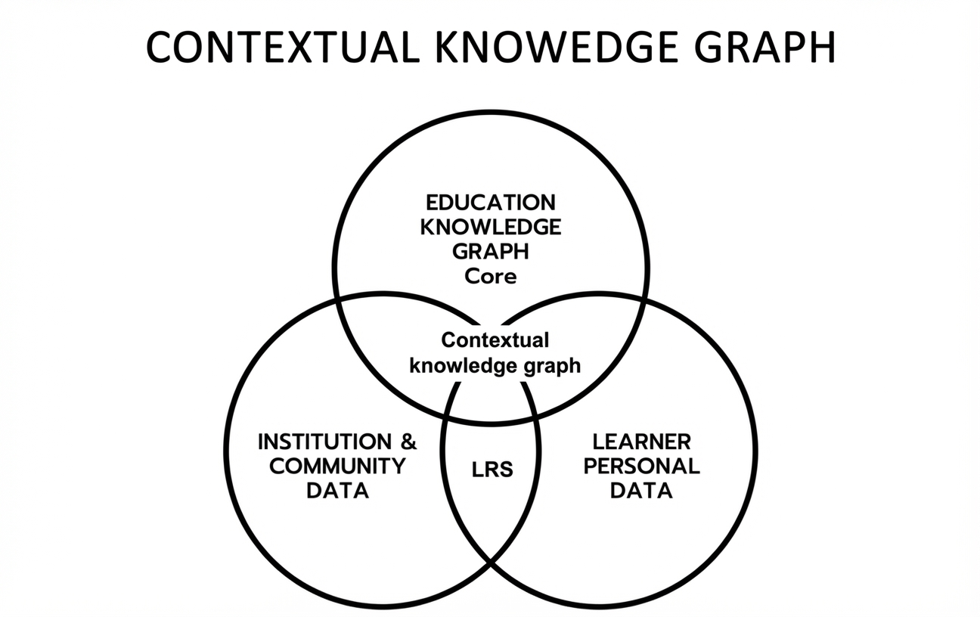
Figure C.6—EDUKG in ITS Context
EDUKG serves as a structured semantic backbone that connects learning content, pedagogical rules, and learner interactions within an intelligent tutoring context. Key use cases include:
- Intelligent tutoring systems (ITS): EDUKGs provide the structured knowledge base for ITS, while LLMs enable natural language interaction. This combination allows for:
  - Dynamic generation of explanations and examples tailored to the learner’s context and prior knowledge.
  - Adaptive question generation based on the learner’s progress and the knowledge graph structure.
  - Semantic understanding of learner queries, facilitating more accurate and context-aware responses.
- Personalized learning pathways: EDUKGs represent the learning domain structure, while adaptive systems use this structure to:
  - Generate individualized learning paths based on learner goals, prior knowledge, and learning style.
  - Dynamically adjust learning paths based on real-time performance data and learner feedback.
  - Incorporate LLM-generated content to fill gaps in the curriculum or provide additional explanations.
- Curriculum mapping and design: EDUKGs provide a comprehensive view of the curriculum, which can be enhanced by:
  - Using LLMs to analyze and suggest improvements in curriculum coherence and progression.
  - Identifying cross-disciplinary connections and opportunities for integrated learning experiences.
  - Enabling adaptive curriculum adjustments based on aggregated learner performance data.
- Intelligent content recommendation: Combining EDUKGs with LLMs and adaptive systems enables:
  - Context-aware recommendation of learning resources aligned with the learner’s knowledge state and objectives.
  - Dynamic creation of supplementary learning materials guided by the knowledge structure in the EDUKG.
  - Adaptive pacing of content delivery based on prerequisite relationships and learner progress.
- Knowledge discovery and analytics: The integration of EDUKGs, LLMs, and adaptive systems facilitates:
  - Advanced pattern recognition in learning behaviors and outcomes across large learner populations.
  - Natural language querying of complex educational datasets.
  - Predictive modeling of student performance and engagement to support proactive interventions.
- Adaptive assessment: EDUKGs provide the structural foundation for adaptive assessments, while LLMs enhance their functionality through:
  - Dynamic generation of assessment items based on the learner’s knowledge state.
  - Intelligent analysis of open-ended responses.
  - Adaptive selection of assessment strategies based on learner characteristics and performance patterns.
By leveraging the synergies between Educational Knowledge Graphs, Large Language Models, and adaptive instructional systems, educational technology can provide more personalized, effective, and engaging learning experiences. This integration enables data-driven decision-making at all levels of education, from individual learner support to institutional policy formulation.
  - Embedding database and language model integration
    - Embedding databases for semantic search
Embedding databases provide a scalable and efficient way to perform semantic search and similarity-based retrieval within the EDUKG. These databases leverage vector embeddings, which are dense numerical representations of entities and concepts, to capture semantic relationships and enable fast and accurate search results.
To integrate an embedding database with the EDUKG, the following steps can be taken:
- Entity Embedding: Each entity in the knowledge graph, such as courses, learning resources, or learners, is mapped to a high-dimensional vector space. These embeddings capture the semantic meaning and relationships between entities based on their context within the knowledge graph.
- Indexing: The entity embeddings are indexed in the embedding database, allowing for efficient similarity-based retrieval. Embedding databases typically use specialized indexing structures, such as approximate nearest neighbor (ANN) algorithms, to enable fast and scalable search operations.
- Semantic Search: When a user performs a search query, the query is also mapped to the same vector space as the entity embeddings. The embedding database then retrieves the most similar entities based on the cosine similarity or other distance metrics between the query vector and the indexed entity vectors.
- Result Ranking and Filtering: The retrieved entities are ranked based on their similarity scores and can be further filtered or refined based on additional criteria, such as entity type, properties, or user preferences.
By integrating an embedding database with the EDUKG, users can perform semantic searches that go beyond traditional keyword-based matching. This enables the discovery of relevant educational content, the identification of similar learners or educators, and the recommendation of personalized learning resources based on semantic similarity.
    - Language model integration for question answering and content generation
LLMs have demonstrated remarkable capabilities in natural language understanding and generation. Integrating LLMs with the EDUKG can enable advanced question-answering and content-generation features, enhancing the usability and value of the knowledge graph.
To integrate LLMs with the EDUKG, the following approaches can be employed:
- Knowledge graph grounding: The LLM is trained on a large corpus of text data, which may include educational content and domain-specific knowledge. By aligning the LLM’s training data with the entities and relationships in the EDUKG, the model can ground its understanding and generate responses that are consistent with the knowledge graph’s structure and semantics.
- Entity linking: When a user asks a question or provides a prompt, the LLM can perform entity linking to identify and disambiguate the mentioned entities within the EDUKG. This allows the model to retrieve relevant information from the knowledge graph and incorporate it into its generated responses.
- Graph-Augmented generation: The LLM can leverage the structure and relationships of the EDUKG to generate more coherent and contextually relevant content. By traversing the graph and considering the connected entities and their properties, the model can produce responses that are grounded in the educational domain and aligned with the knowledge graph’s ontology.
- Feedback and refinement: The generated content can be further refined and validated based on feedback from subject matter experts or through comparison with the knowledge graph’s existing data. This iterative process helps improve the quality and accuracy of the generated content over time.
By integrating LLMs with the EDUKG, users can engage in natural language interactions, asking questions and receiving informative answers based on the collective knowledge captured in the graph. LLMs can also assist in the creation of new educational content, such as course descriptions, learning objectives, or assessment questions, by generating text that is consistent with the knowledge graph’s structure and domain-specific conventions.
The combination of embedding databases and LLMs with the EDUKG opens up new possibilities for semantic search, question answering, and content generation, enhancing the accessibility and utility of educational knowledge for learners, educators, and researchers alike.
  - Applying EDUKG as AIED component
    - KG for representation
The EDUKG is designed to provide a comprehensive and flexible representation of educational knowledge. It allows for the integration of diverse data sources, such as curricula, learning materials, assessment data, and student performance records, into a unified and structured format. The graph-based nature of the EDUKG enables the representation of complex relationships and dependencies between educational entities, facilitating advanced analytics and personalized learning applications.
    - KG for actioning or recommendation
The EDUKG can be leveraged for various actioning and recommendation tasks in educational settings. By traversing the graph and analyzing the relationships between entities, intelligent systems can provide personalized learning recommendations, suggest relevant learning resources, and adapt instructional strategies based on individual learner profiles and performance data. The EDUKG’s rich semantic structure allows for the implementation of sophisticated recommendation algorithms and adaptive learning approaches.
Pedagogy rules play a crucial role in actioning and recommendation. They represent the strategies, guidelines, and rules that govern the design, delivery, and evaluation of instruction. By incorporating pedagogy rules into the EDUKG, the system can make informed decisions about learning paths, teaching strategies, difficulty progression, and feedback mechanisms. The attributes of pedagogy rules, such as applicability conditions, effectiveness scores, and associated tasks, enable the system to select and apply appropriate instructional approaches based on the learner’s context and performance.
    - KG for semantic reasoning
The EDUKG’s ontology-based structure enables semantic reasoning and inference capabilities. By leveraging the defined classes, properties, and relationships, educational applications can perform logical reasoning tasks, such as:
- Identifying prerequisite knowledge for a given learning point
- Determining the most suitable learning resources for a specific topic or skill level
- Inferring the mastery level of a student based on their performance data
- Generating personalized learning paths or curriculum sequences
Semantic reasoning over the EDUKG can help in automating decision-making processes, providing intelligent support for learners and educators, and enabling adaptive and personalized learning experiences.

(informative)
Case studies
  - Case study: Personalized learning platform
A leading educational technology company developed a personalized learning platform powered by an EDUKG. The platform integrates data from various sources, including learning management systems, educational content providers, and student assessments, to create a comprehensive knowledge base of educational concepts, resources, and learner profiles.
For this example, the knowledge graph is built using RDF and SPARQL, with Apache Jena as the RDF data store and Stardog as the graph database. The platform leverages embedding databases to enable semantic search and recommendation of learning resources based on learner preferences and performance.
The personalized learning platform also incorporates LLMs to provide intelligent tutoring and adaptive assessment capabilities. Learners can interact with the platform using natural language, asking questions and receiving guidance tailored to their individual needs.
The platform has achieved significant technical milestones, including:
- Integrating data from over 100 different sources, resulting in a knowledge graph with millions of triples.
- Enabling real-time personalization and recommendation of learning resources based on learner profiles and performance data.
- Achieving high accuracy in predicting learner mastery of concepts and suggesting targeted interventions.
- Providing natural language interaction capabilities that enhance learner engagement and support.
  - Case study: Research collaboration platform
A research university developed a collaboration platform to facilitate interdisciplinary research and knowledge sharing among its faculty and students. The platform leverages an EDUKG to connect researchers, projects, publications, and datasets across different domains.
For this example, the knowledge graph is implemented using RDF and SPARQL, with Apache Fuseki as the SPARQL endpoint and Neo4j as the graph database. The platform integrates embedding databases to enable semantic search and recommendation of research resources and potential collaborators.
The collaboration platform also utilizes LLMs to automatically extract key information from research papers and generate summaries and keyword tags. Researchers can use natural language queries to discover relevant content and expertise within the university.
The platform has achieved notable technical successes, including:
- Integrating data from the university’s research information management system, institutional repository, and grant databases, creating a unified knowledge base of research activities.
- Enabling semantic search and recommendation of research resources and collaborators based on research interests and expertise.
- Automating the extraction of key information from research papers, reducing manual effort and improving discoverability.
- Facilitating cross-disciplinary collaboration and knowledge sharing among researchers, leading to increased research output and impact.
These case studies demonstrate the technical feasibility and benefits of implementing EDUKGs in different educational contexts. By leveraging RDF, SPARQL, graph databases, embedding databases, and LLMs, these platforms have achieved significant improvements in personalized learning, research collaboration, and knowledge discovery.

Annex E
(informative)
EDUKG implementation
  - Knowledge graph DB construction
    - General
A knowledge graph database is a specialized database designed to store, manage, and query data represented as a graph. Unlike traditional relational databases, a knowledge graph database represents entities as nodes, relationships as edges, and properties as attributes, enabling the modeling of complex interconnections between data elements. Knowledge graph databases provide efficient mechanisms for traversing relationships, performing graph pattern queries, and integrating heterogeneous datasets.
In the context of EDUKG, a knowledge graph database serves as the backbone for storing educational entities (such as courses, learning resources, and learners) and the relationships between them, enabling semantic representation, reasoning, and advanced analytics. By leveraging RDF-compatible databases or dedicated graph databases, EDUKG can support interoperable, scalable, and flexible educational applications.
    - RDF-Compatible databases
To maintain semantic web compatibility and enable seamless data exchange, the EDUKG is constructed using RDF-compatible databases. These databases provide native support for storing and querying RDF data.
When constructing the knowledge graph database, it is essential to adhere to RDF best practices and standards, including:
- Using well-defined ontologies and vocabularies to model educational entities, relationships, and properties.
- Assigning unique URIs to each entity to achieve unambiguous identification across the graph.
- Representing statements as RDF triples (subject, predicate, object) to capture the relationships between entities.
- Utilizing RDF serialization formats, such as RDF/XML, Turtle, or JSON-LD, for data exchange and interoperability.
By following RDF standards and leveraging RDF-compatible databases, the EDUKG becomes an integral part of the Semantic Web ecosystem, enabling seamless integration with other educational datasets and systems.
    - Knowledge graph database options
In addition to RDF-compatible databases, the EDUKG can also leverage dedicated graph databases for efficient storage and querying. Graph databases are optimized for handling large-scale graph data and provide native support for graph traversal and pattern matching.
Graph databases offer several advantages for constructing the EDUKG:
- Efficient Traversal: Graph databases are designed to efficiently traverse relationships between entities, enabling fast and complex queries that involve multiple hops across the graph.
- Flexible Schema: Graph databases allow for a flexible and evolving schema, accommodating the dynamic nature of educational data and the addition of new entity types and relationships as the knowledge graph grows.
- Scalability: Graph databases are built to handle large-scale graph data, providing horizontal scalability and distributed processing capabilities to accommodate the expanding size of the EDUKG.
- Graph Algorithms: Many graph databases offer built-in graph algorithms, such as shortest path, centrality measures, and community detection, which can be applied to the EDUKG for advanced analytics and insights.
When selecting a graph database for the EDUKG, it is important to consider factors such as RDF compatibility, performance, scalability, and integration with existing educational systems and tools.
  - Data integration, harmonization, and quality
Integrating and harmonizing data from diverse educational sources is a critical aspect of constructing a comprehensive and reliable EDUKG. This subclause discusses advanced data harmonization techniques and highlights the role of RDF in supporting data quality and interoperability. As illustrated in Fig. 11, learning record data captured by Learning Record Stores (LRS) are integrated with the EDUKG to form a unified semantic layer that enables cross-system data alignment, analytics, and interoperability.

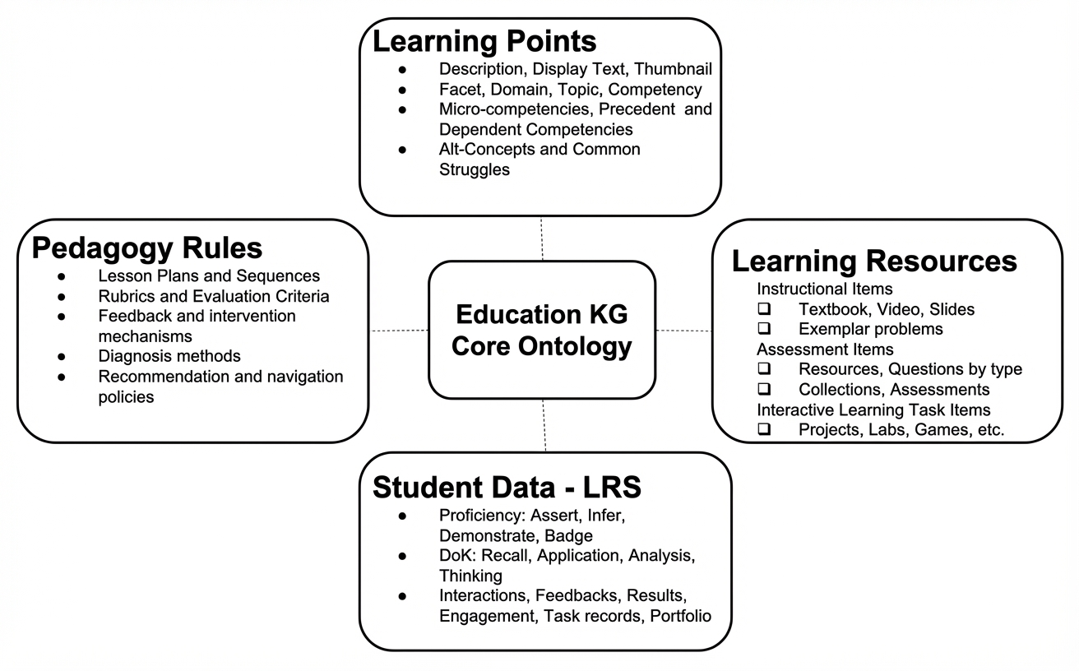
Figure E.2—EDUKG with LRS
    - Data integration techniques
The EDUKG aims to integrate data from various educational systems, databases, and repositories, such as learning management systems, student information systems, digital libraries, and open educational resources. To achieve seamless integration, the following techniques can be employed:
- Ontology Alignment: Aligning the ontologies used by different data sources is essential to establishing a common semantic framework. Ontology alignment techniques, such as schema matching and entity resolution, help in identifying and mapping equivalent concepts and properties across different ontologies.
- Data Transformation: Raw educational data often comes in different formats and structures. Data transformation techniques, such as data cleaning, normalization, and conversion, are applied to convert the data into a consistent RDF representation that adheres to the EDUKG’s ontology.
- Linked Data Principles: By following Linked Data principles, such as using HTTP URIs to name entities and providing RDF descriptions, educational data becomes part of the global data web. This enables the EDUKG to establish links with other relevant datasets, enhancing data richness and discoverability.
    - RDF for data quality and interoperability
RDF plays a crucial role in supporting data quality and interoperability within EDUKG. RDF provides a standardized and machine-readable format for representing educational data, enabling consistent data modeling and exchange across different systems and platforms.
EDUKG follows RDF best practices in its implementation, including:
- Consistent Use of Ontologies: Adopting widely accepted educational ontologies, such as the Learning Resource Metadata Initiative (LRMI) or the Credential Transparency Description Language (CTDL), provide semantic consistency and facilitates data integration and interoperability.
- Data Validation: Implementing data validation mechanisms, such as RDF Schema (RDFS) and Web Ontology Language (OWL) constraints, helps in enforcing data integrity and detecting inconsistencies or errors in the graph.
- Data Provenance: Capturing data provenance information, such as the source, timestamp, and method of data acquisition, enhances data transparency and trustworthiness. RDF provides mechanisms, such as the PROV Ontology, to represent and track data provenance.
- Data Versioning: Maintaining version control for the EDUKG allows for tracking changes over time and enables reproducibility and data lineage analysis. RDF versioning strategies, such as named graphs or the Memento framework, can be employed to manage different versions of the graph.
By leveraging RDF for data representation and adhering to data quality principles, the EDUKG provides the reliability, consistency, and interoperability of educational data, enabling seamless data exchange and integration with other systems and datasets.
  - Querying and interaction
Efficient querying and interaction with the EDUKG are essential for extracting valuable insights and supporting various educational applications. This subclause focuses on utilizing SPARQL for querying the knowledge graph and explores compatibility with other query languages and mechanisms.
    - SPARQL querying
SPARQL (SPARQL Protocol and RDF Query Language) is the standard query language for RDF data. It provides a powerful and expressive way to retrieve and manipulate information stored in the EDUKG.
SPARQL queries consist of graph patterns that match the desired data in the knowledge graph. These patterns can include:
- Triple Patterns: Basic patterns that match specific subject-predicate-object triples in the graph.
- Optionals: Patterns that allow for the inclusion of optional data in the query results.
- Filters: Conditions that restrict the query results based on specific criteria.
- Aggregates: Functions that perform calculations or aggregations over the query results.
- Property Paths: Expressions that navigate through a sequence of relationships in the graph.
SPARQL queries can be used to answer a wide range of educational questions, such as:
- Retrieving all courses taught by a specific educator.
- Finding learning resources related to a particular topic.
- Identifying learners who have completed a set of prerequisite courses.
- Calculating the average duration of learning resources in a specific subject area.
To facilitate effective querying, the EDUKG provide a SPARQL endpoint, a web-based interface that accepts SPARQL queries and returns the results in a standardized format (e.g., JSON or XML). The endpoint is well-documented, with clear instructions on how to construct queries and interpret the results.
    - Compatibility with other query languages
While SPARQL is the standard query language for RDF data, the EDUKG may also support compatibility with other query languages and mechanisms, depending on the specific database technology used.

EDUKG may provide query translation mechanisms that allow users to write queries in their preferred language and translate them into equivalent SPARQL queries. This approach enables users to leverage the full potential of the knowledge graph while using familiar query languages and tools.
    - Query optimization and performance
Efficient querying is crucial for the usability and scalability of the EDUKG. To optimize query performance, the following strategies can be employed:
- Indexing: Implementing appropriate indexing techniques, such as subject-predicate-object indexes or path indexes, can significantly accelerate query execution by reducing the search space.
- Query Optimization: Employing query optimization techniques, such as query rewriting, join ordering, or parallel execution, can improve query efficiency and reduce response times.
- Caching: Implementing caching mechanisms, such as query result caching or materialized views, can speed up frequently accessed queries by storing precomputed results.
- Partitioning: Partitioning the knowledge graph based on specific criteria, such as subject domains or entity types, can enable distributed query processing and improve scalability.
By providing efficient and flexible querying capabilities, the EDUKG empowers users to extract valuable insights, discover hidden patterns, and support a wide range of educational applications and research endeavors.

(informative)
Bibliography
Bibliographical references are resources that provide additional or helpful material but do not need to be understood or used to implement this standard. Reference to these resources is made for informational use only.
- ISO/IEC 21838-1:2021, Information technology – top-level ontologies (tlo) – part 1: Requirements.
- ISO/IEC 21838-2:2021, Information technology – top-level ontologies (tlo) – part 2: Basic formal ontology (bfo) (International Organization for Standardization).
- ISO/IEC 24707:2018, Information technology – common logic (cl) – a framework for a family of logic-based languages (International Organization for Standardization).

- IEEE P2247.1, IEEE Draft Standard for Conceptual Model for Adaptive Instructional System.

- IEEE Std 9274.1.1™-2023, IEEE Standard for Learning Technology—JavaScript Object Notation (JSON) Data Model Format and Representational State Transfer (RESTful) Web Service for Learner Experience Data Tracking and AccessExperience API (xAPI) Standard Data Privacy Process.

- Cyganiak R, Wood D, Lanthaler M (2014) Rdf 1.1 concepts and abstract syntax (W3C), W3c recommendation. Available at https://www.w3.org/TR/rdf11-concepts/.
- Brickley D, Guha R (2014) Rdf schema 1.1 (W3C), W3c recommendation. Available at https://www.w3.org/TR/rdf-schema/.
- Group WOW (2012) Owl 2 web ontology language document overview (second edition) (W3C), W3c recommendation. Available at https://www.w3.org/TR/owl2-overview/.
- Miles A, Bechhofer S (2009) Skos simple knowledge organization system reference (W3C), W3c recommendation. Available at https://www.w3.org/TR/skos-reference/.
- Harris S, Seaborne A (2013) Sparql 1.1 query language (W3C), W3c recommendation. Available at https://www.w3.org/TR/sparql11-query/.
- DCMI Usage Board (2012) Dcmi metadata terms (Dublin Core Metadata Initiative), Available at https://www.dublincore.org/specifications/dublin-core/dcmi-terms/.
- Tong RJ, Hu X (2024) Future of education with neuro-symbolic ai agents in self-improving adaptive instructional systems. Frontiers of Digital Education 1(2):198 (pages 14). Available at https://journal.hep.com.cn/fde/EN/10.1007/s44366-024-0008-9.
- W3C. SPARQL 1.1 Query Language. World Wide Web Consortium Recommendation, 21 March 2013. Available at: https://www.w3.org/TR/sparql11-query/
- W3C Recommendation, RDF 1.1 Turtle: Terse RDF Triple Language, World Wide Web Consortium (W3C), Feb. 25, 2014. [Online]. Available: https://www.w3.org/TR/turtle/
- W3C Recommendation, OWL 2 Web Ontology Language Document Overview, World Wide Web Consortium (W3C), Dec. 11, 2012. [Online]. Available: https://www.w3.org/TR/owl2-overview/

The Institute of Electrical and Electronics Engineers, Inc. 3 Park Avenue, New York, NY 10016-5997, USA Copyright © 2026 by The Institute of Electrical and Electronics Engineers, Inc. All rights reserved. Published <Date Published>. Printed in the United States of America. IEEE is a registered trademark in the U.S. Patent & Trademark Office, owned by The Institute of Electrical and Electronics Engineers, Incorporated. PDF: ISBN 978-0-XXXX-XXXX-X STDXXXXX Print: ISBN 978-0-XXXX-XXXX-X STDPDXXXXX IEEE prohibits discrimination, harassment, and bullying. For more information, visit https://www.ieee.org/about/corporate/governance/p9-26.html. No part of this publication may be reproduced in any form, in an electronic retrieval system or otherwise, without the prior written permission of the publisher.
Available at: https://development.standards.ieee.org/myproject-web/public/view.html#landing.
Available at: https://standards.ieee.org/about/contact/.
Available at: https://ieeexplore.ieee.org/browse/standards/collection/ieee.
Available at: https://standards.ieee.org/standard/index.html.
Available at: https://standards.ieee.org/about/sasb/patcom/materials.html.
The use of the word must is deprecated and cannot be used when stating mandatory requirements; must is used only to describe unavoidable situations.
The use of will is deprecated and cannot be used when stating mandatory requirements; will is only used in statements of fact.
IEEE Standards Dictionary Online is available at: http://dictionary.ieee.org. An IEEE account is required for access to the dictionary, and one can be created at no charge on the dictionary sign-in page.
The numbers in brackets correspond to those of the bibliography in Annex E.
Any product included in this standard is for the convenience of the user and does not constitute an endorsement from IEEE.

